**Roll No.: 16010122096  
 16010122109  
 16010122255**

**Group No: 8**

**Name of the student: Romil Lodaya   
 Aakriti Mehta  
 Siddhi Somaiya**

**Div: TY Div C**

**Branch: Computer Engineering**

**IA No: IA1**

**Date: 9 / 2 / 25**

**Subject: Information Security**

|  |
| --- |
| **TITLE:**  Implementation of BurpSuite for Web Application Penetration Testing: A Case Study on Authentication  **AIM:** To implement Burp Suite for web penetration testing, focusing on identifying vulnerabilities |

**Literature survey/Theory:**

Web application penetration testing is a vital practice in cybersecurity, as it helps ensure applications are robust against common threats like SQL injection, Cross-Site Scripting (XSS), and Broken Authentication. One of the most effective tools for conducting web application security assessments is **Burp Suite**, a widely used platform that offers comprehensive functionality for vulnerability identification and mitigation. Security professionals use Burp Suite to intercept, analyze, and modify web traffic, making it an essential tool for pinpointing weaknesses within web applications.

According to the 2023 OWASP Top 10, 94% of applications have critical authentication flaws, and 67% are vulnerable to XSS attacks. Burp Suite is a widely used security testing tool that intercepts, analyzes, and modifies web traffic to uncover vulnerabilities.

**Key Areas of Web Security Testing:**

* **Broken Authentication:** Poor session management allows attackers to hijack user accounts.
* **Cross-Site Scripting (XSS):** Injecting malicious scripts to execute in client-side browsers.
* **SQL Injection:** Manipulating SQL queries to access sensitive information.
* **CSRF (Cross-Site Request Forgery):** Exploiting user actions to perform unauthorized changes.
* **IDOR (Insecure Direct Object References):** Accessing unauthorized data by modifying object references.
* **API Vulnerabilities:** Exploiting insecure endpoints for unauthorized access.
* **Automated Pentesting:** Using Burp Suite extensions and tools to streamline assessments.

### 

### Concept/Algorithms:

* **Burp Suite Extensions:** Custom-built add-ons that enhance Burp Suite's capabilities by providing additional features and functionality for web security testing.
* **CURL Commands:** Command-line tools used to automate web requests, simulate attacks, or test specific web application behaviors in a more streamlined way.
* **Authentication Testing:** Ensuring the application’s user session management system is secure, preventing vulnerabilities that allow attackers to impersonate valid users.

### 

### 

### 

### 

### Burp Suite Tools:

#### Proxy

* **Function:** Intercepts and modifies HTTP/HTTPS traffic between the browser and the server, enabling testers to analyze and manipulate requests and responses.
* **Use Case:** Helps security testers view sensitive information like session cookies, headers, and parameters during the interaction between the client and server.

#### Intruder

* **Function:** Conducts automated attacks like brute force or dictionary attacks to find weaknesses such as incorrect input validation or weak authentication mechanisms.
* **Use Case:** Primarily used for testing login forms, password fields, or any part of an application susceptible to attack through multiple inputs.

#### Repeater

* **Function:** Allows the tester to send and modify HTTP requests multiple times to test the application’s response to various inputs.
* **Use Case:** Ideal for manually testing and manipulating requests in a controlled manner, observing how the server responds to different payloads.

#### Sequencer

* **Function:** Analyzes the randomness and predictability of session tokens, cookies, or other identifiers to assess the security of session management.
* **Use Case:** Used to determine how strong the randomness of a session token is, making it a critical tool in detecting weak session handling vulnerabilities.

#### Comparer

* **Function:** Compares responses and identifies differences between requests to detect information leaks or anomalies.
* **Use Case:** Useful for analyzing subtle changes in server responses that might reveal sensitive information or security flaws.

#### Decoder

* **Function:** Converts obfuscated or encoded data (e.g., Base64, URL encoding) into a readable format, aiding in the analysis of encoded information.
* **Use Case:** Helps testers analyze encoded data like session tokens or hidden fields in requests and responses, identifying sensitive information or potential security flaws.

### 

### Algorithms for Web Security Testing

#### Request Interception Algorithm (Analyzing HTTP Requests)

1. Capture HTTP requests using Burp Suite Proxy.
2. Modify request parameters, headers, or cookies to test for vulnerabilities.
3. Send the modified request to the server.
4. Analyze the response for anomalies, incorrect authorization, or security flaws.

#### Automated Attack Execution (Brute-Force & Injection Attacks)

1. Configure Burp Suite’s Intruder tool with attack payloads (passwords, SQL injection, etc.).
2. Target specific input fields (login forms, search fields, etc.).
3. Launch the attack and analyze the server’s responses.
4. Identify successful exploits and determine security weaknesses.

#### Session Hijacking Detection (Analyzing Authentication Tokens for Security Flaws)

1. Capture session tokens using Burp Suite's Sequencer.
2. Analyze the randomness and entropy of session tokens.
3. Detect patterns or predictability in tokens that could allow session hijacking.
4. Assess the security level of session management and suggest improvements.

**Pseudocode/Flowchart/Implementations/Screenshots with steps:**

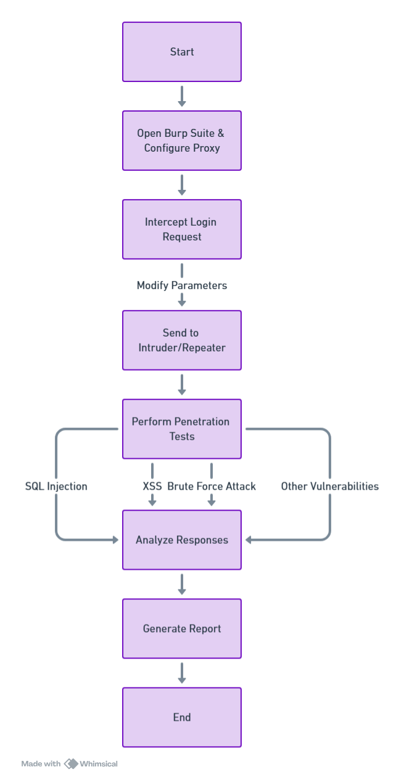

**Tool 1] Proxy:**

The Burp Proxy intercepts requests and responses between the client and the server. It

allows us to capture and modify the requests to test various security issues.

**Step 1:** Trying to send a login request with invalid credentials:

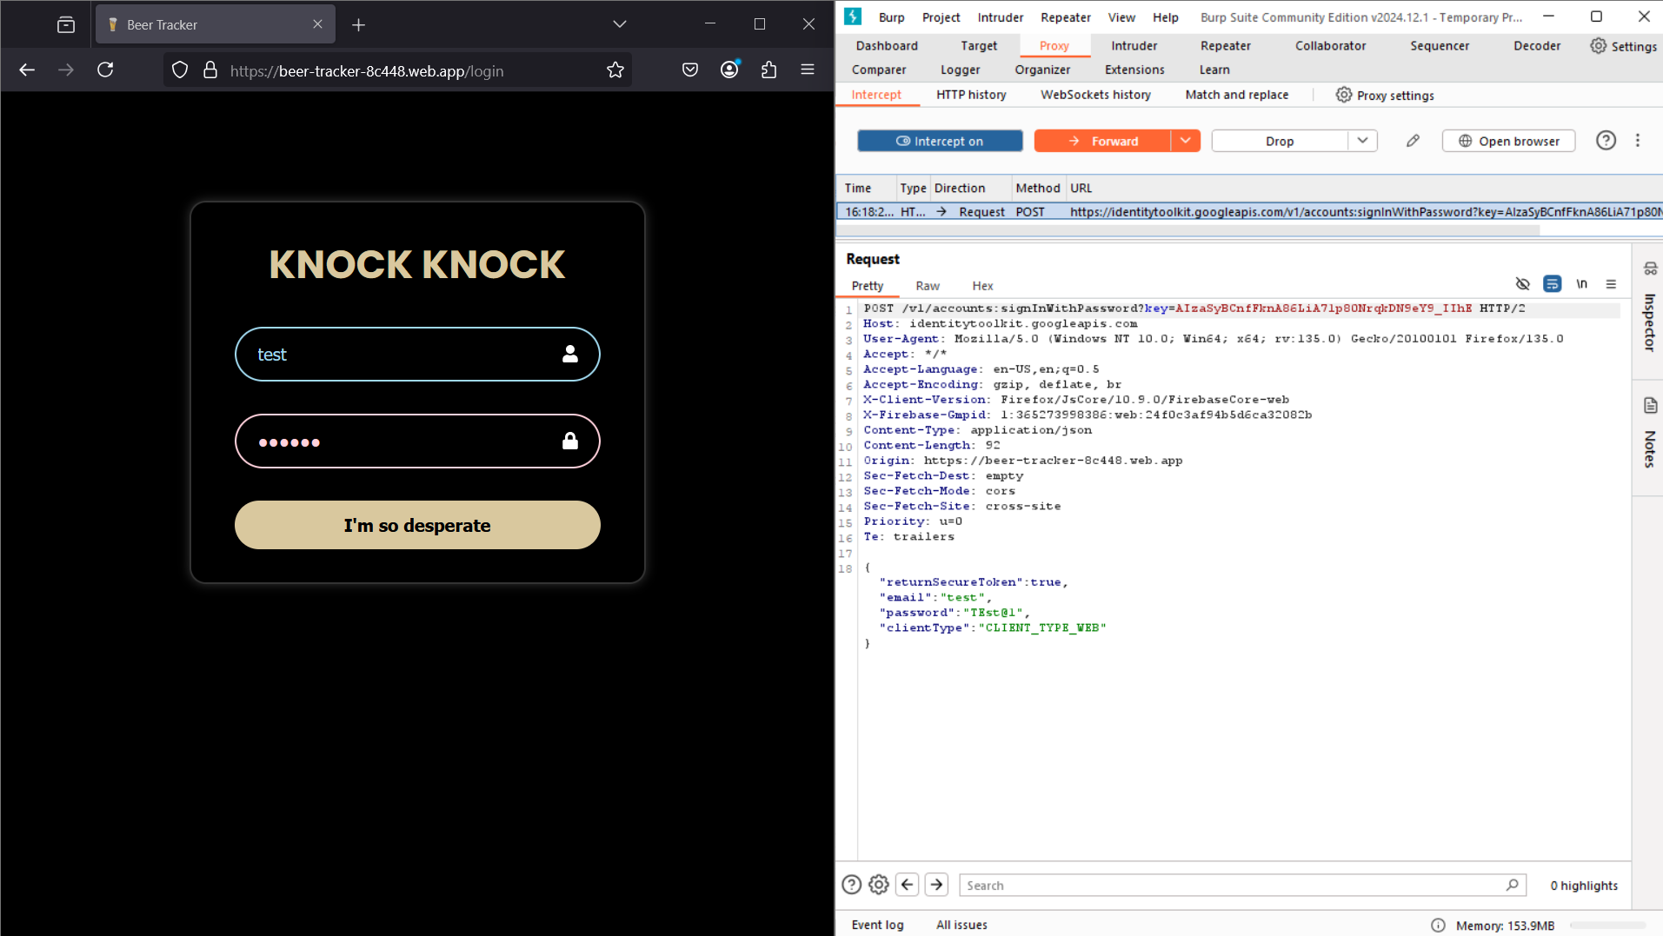

**Step 2:** When forwarding the request with incorrect credentials from Burp Suite, an error occurs during login:

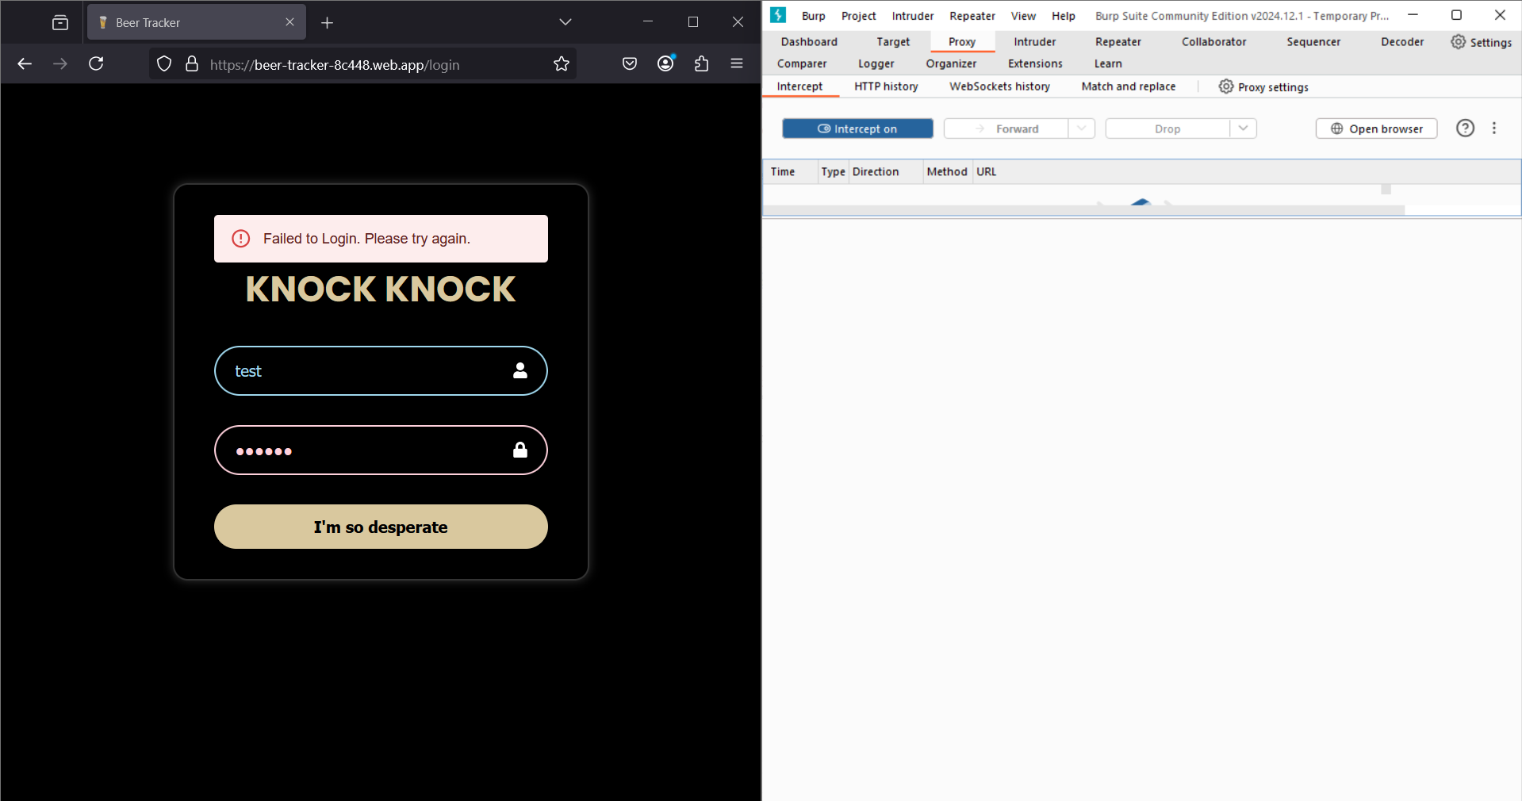

**Step 3:** Now, modifying the request with the correct credentials:

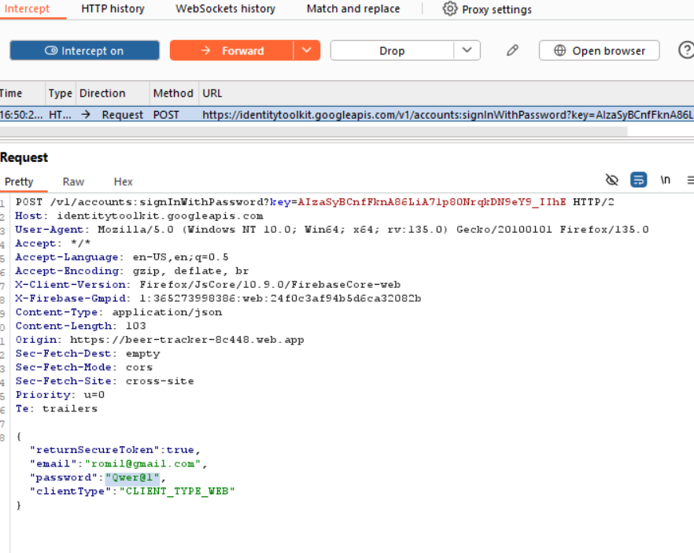

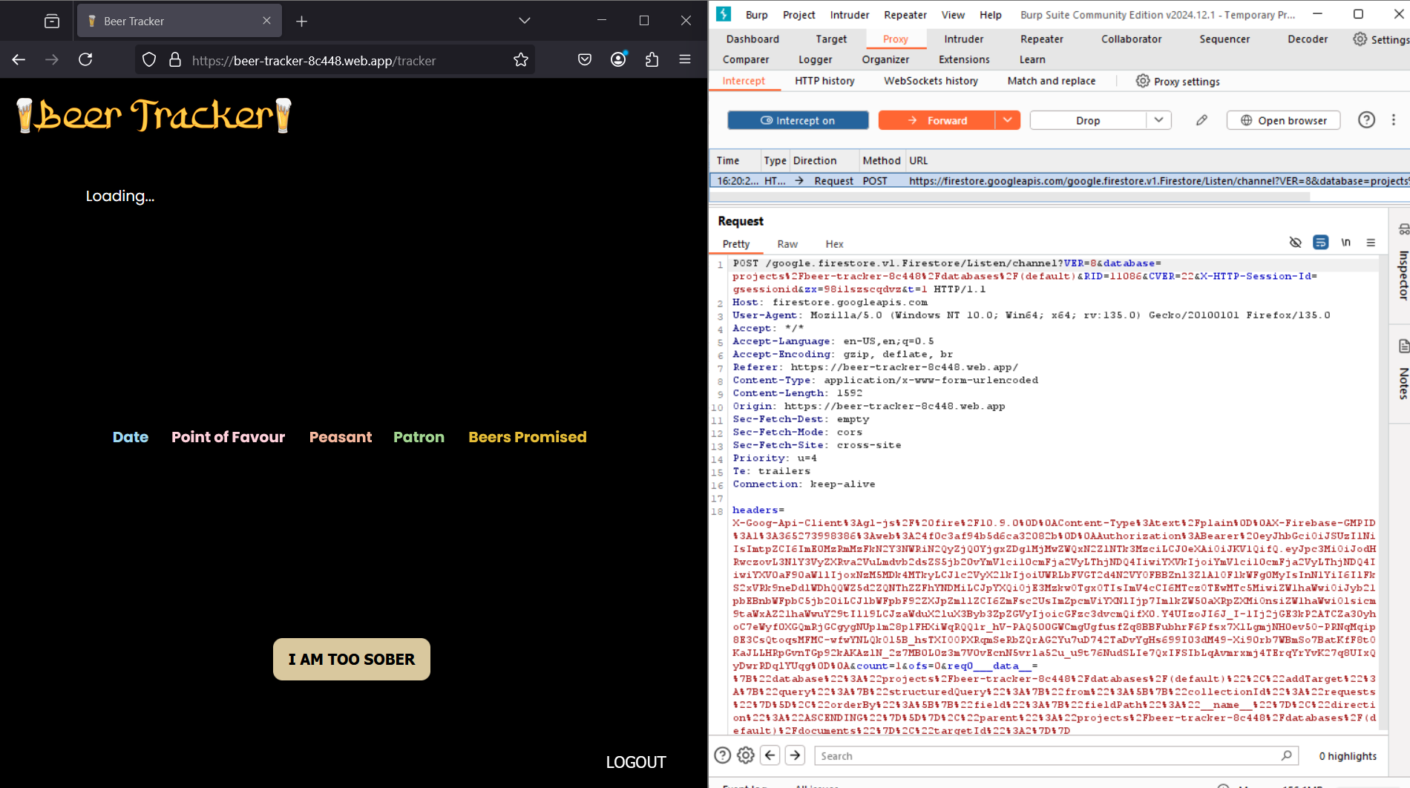

After modifying the request with valid credentials, the login is successful, and we are logged into the site as a user.

Burp Proxy can be used for many attacks such as Man-In-The-Middle (MITM), Injection

Attacks etc.

**Tool 2] Intruder:**

The Burp Intruder is used for automating BruteForce attacks such as password cracking

and entering payloads into defined positions within an HTTP Request. It can also be used

for directory brute forcing.

**Step 1:** First, we will send the login request from the Proxy to the Intruder:

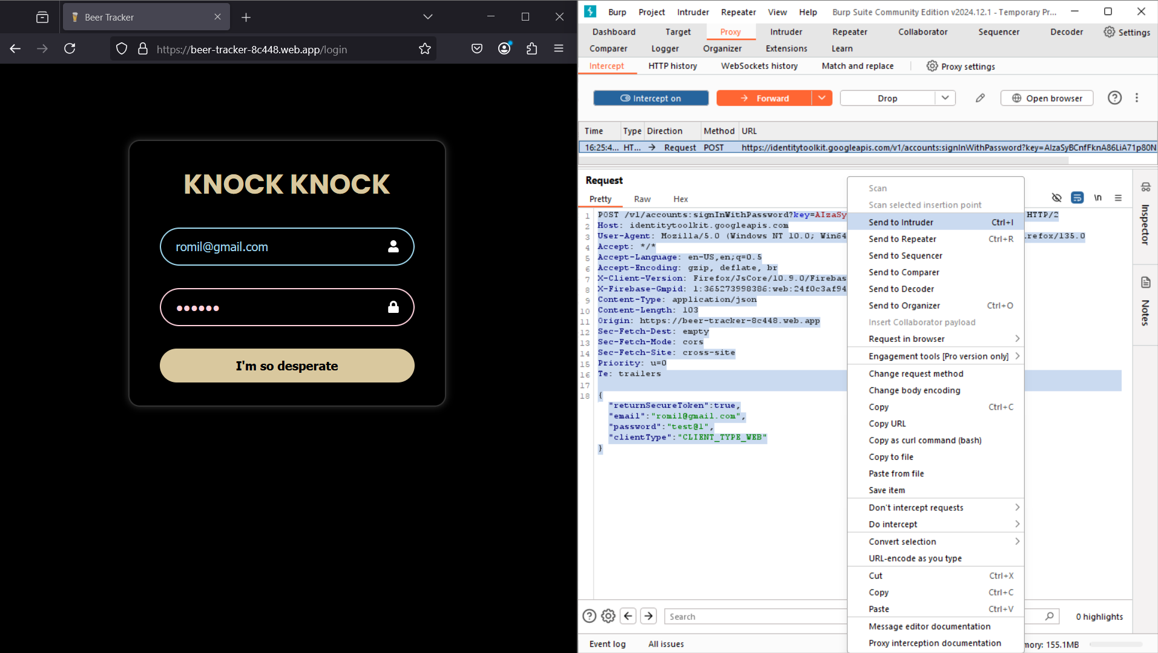

**Step 2:** Let's brute force the password for the user account. So, we add the **§**

around our password to manually select the password field to be tested with our

Directory.

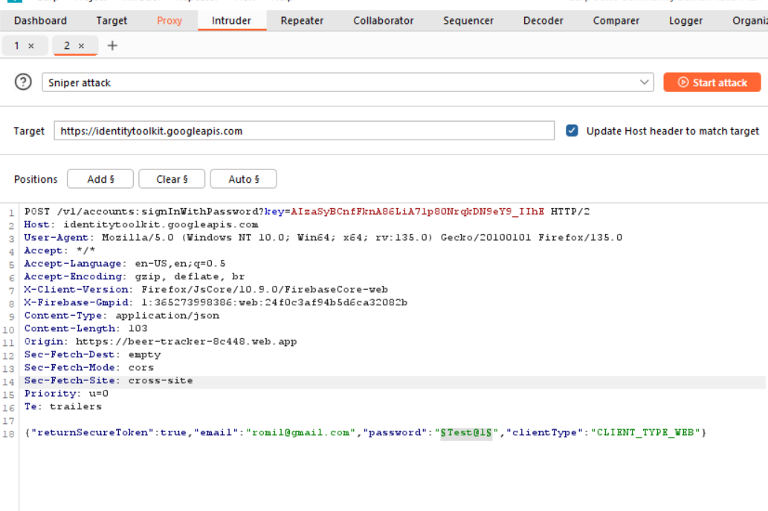

**Step 3:** Now, Let’s add a password list to be tested in the application.

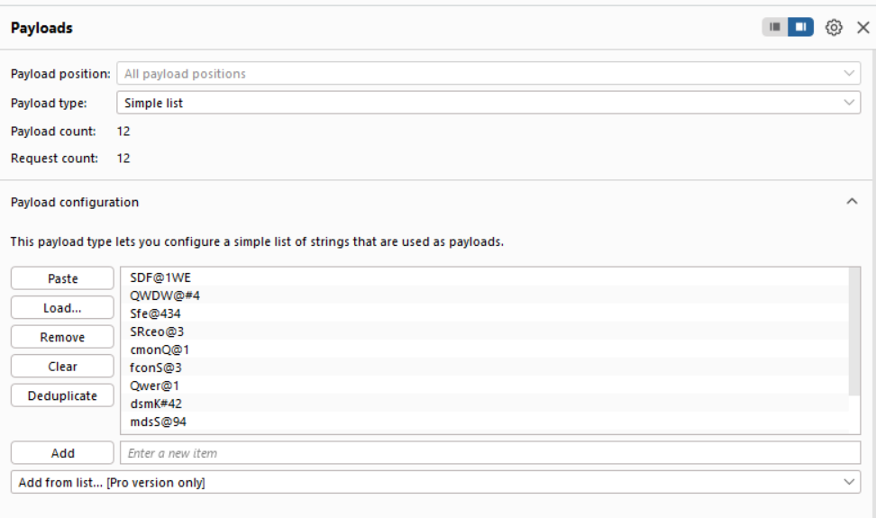

**Step 4:** Now let’s start the attack. It will check all the passwords from the list we uploaded.

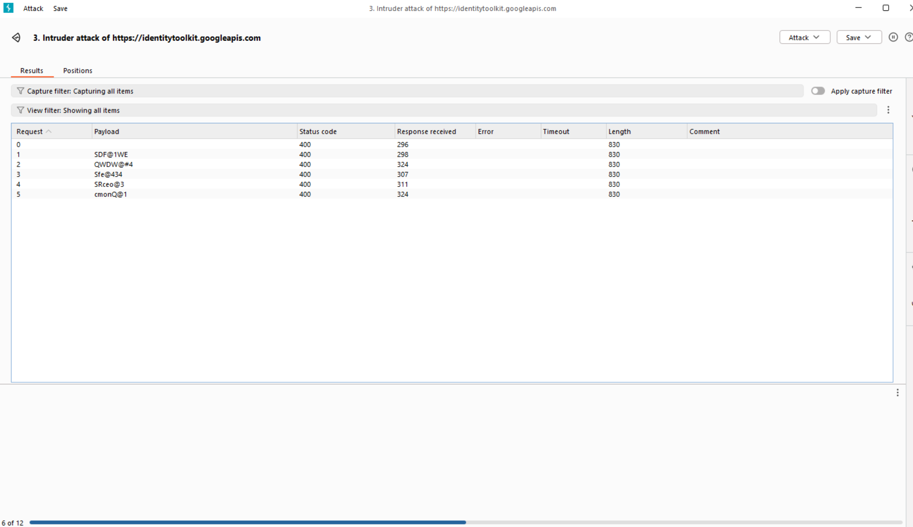

**Step 5:** Once the testing is complete, we can sort all the responses by their status codes to identify the correct password combination.

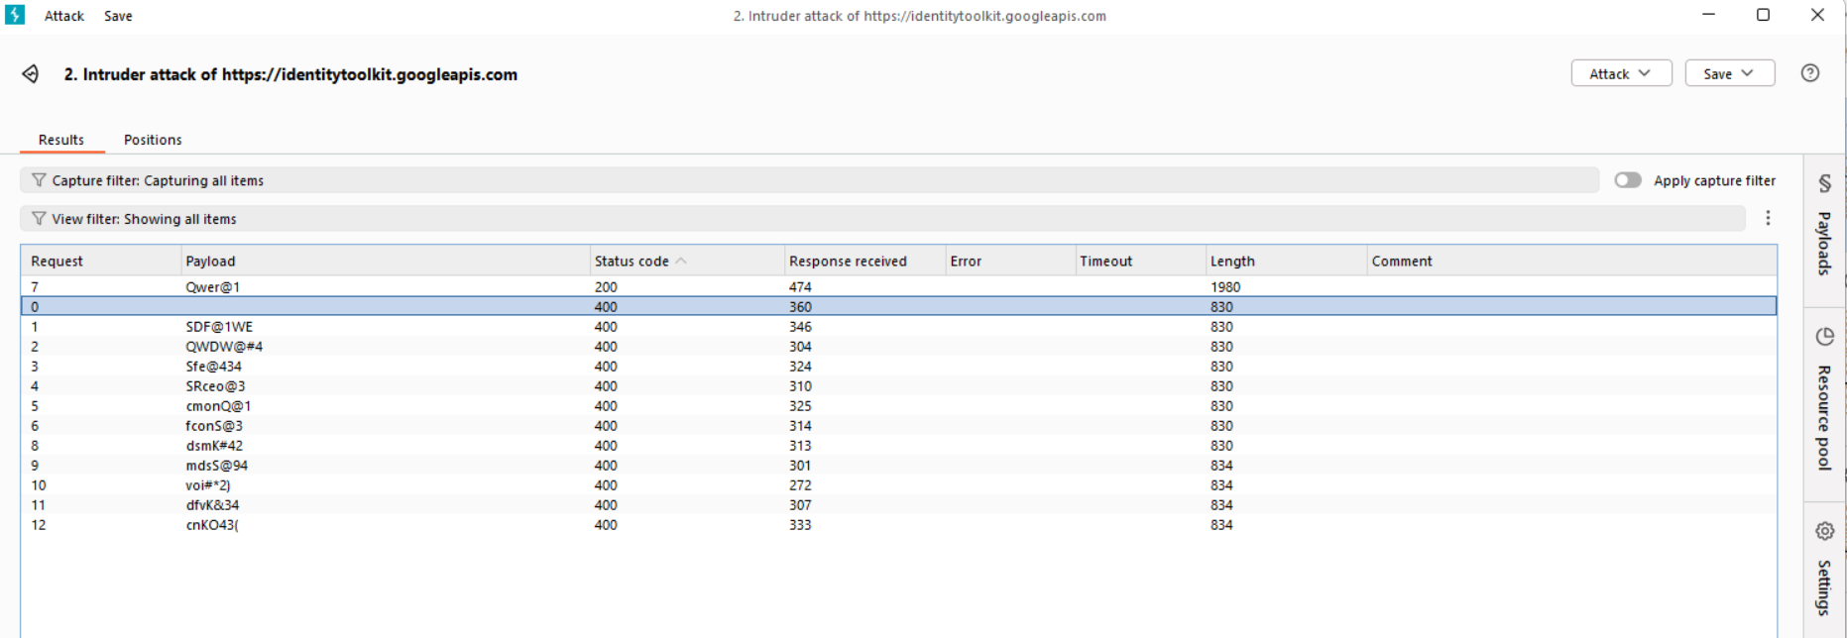

By doing so, we can determine that the correct password is "**Qwer@1**" as it corresponds to the status code 200.

**Tool 3] Repeater:**

The Burp Repeater is a very helpful tool and maybe one of the most used tools in Burp

Suite while testing an application. It allows you to capture a request and send it again and

again to test and find the vulnerabilities or payloads in the application. It has a Request

and a Response section to manually analyze the responses while testing the application.

**Step 1:** Let’s start by sending the request to Burp Repeater.

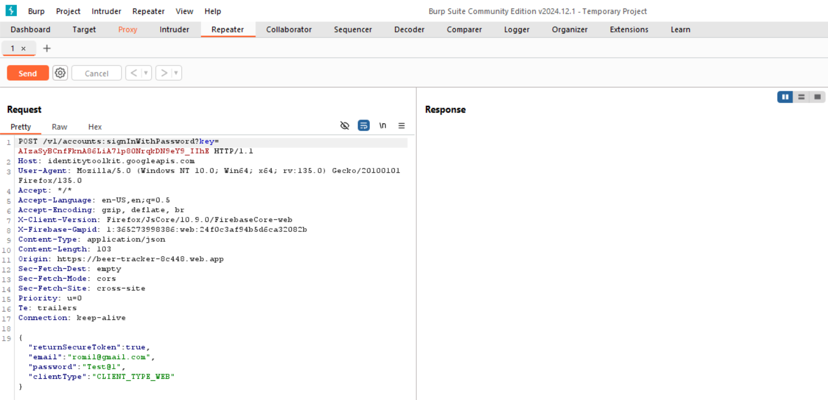

**Step 2:** Test the request using the credentials that were included when the request was intercept.

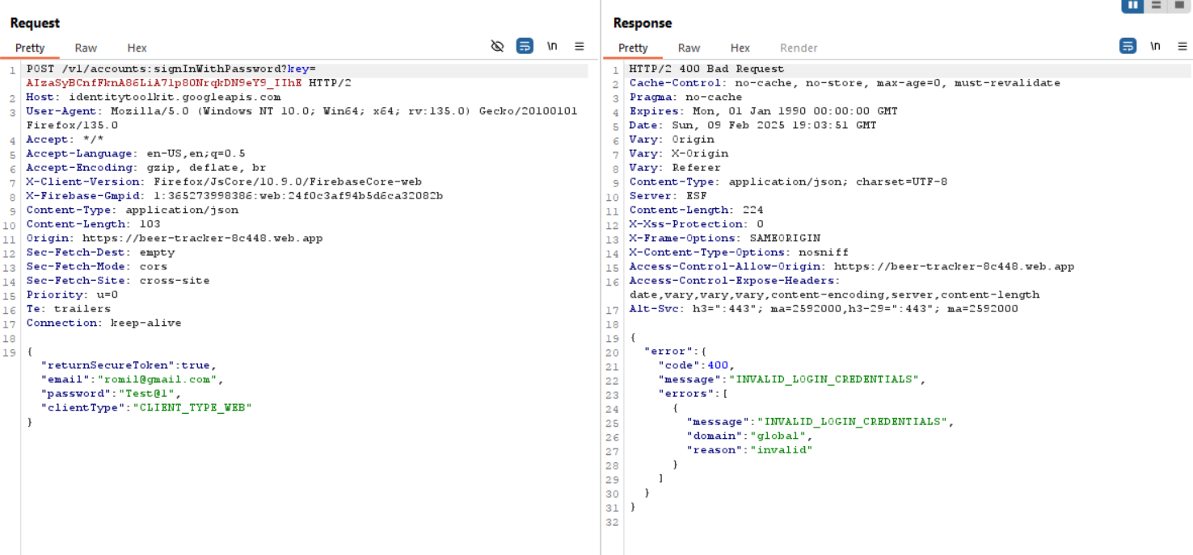

**Step 3:** Now, change the credentials and send the request again to see the system’s response.

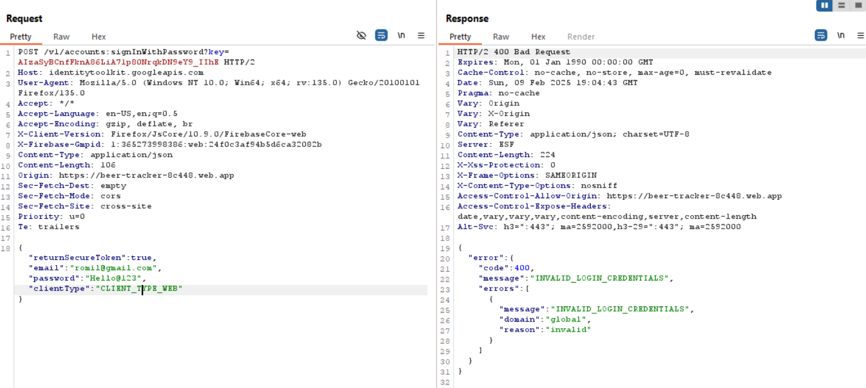

**Step 4:** Finally, enter valid credentials and resend the request. Upon success, you’ll receive the email ID and token ID, confirming that you are logged in successfully.

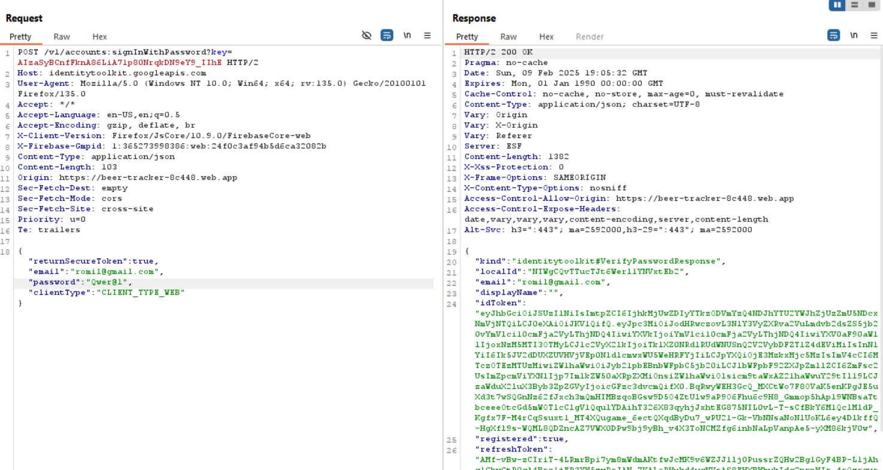

The requests and responses can also be viewed in various formats for easier analysis, but the data inside the request remains the same.

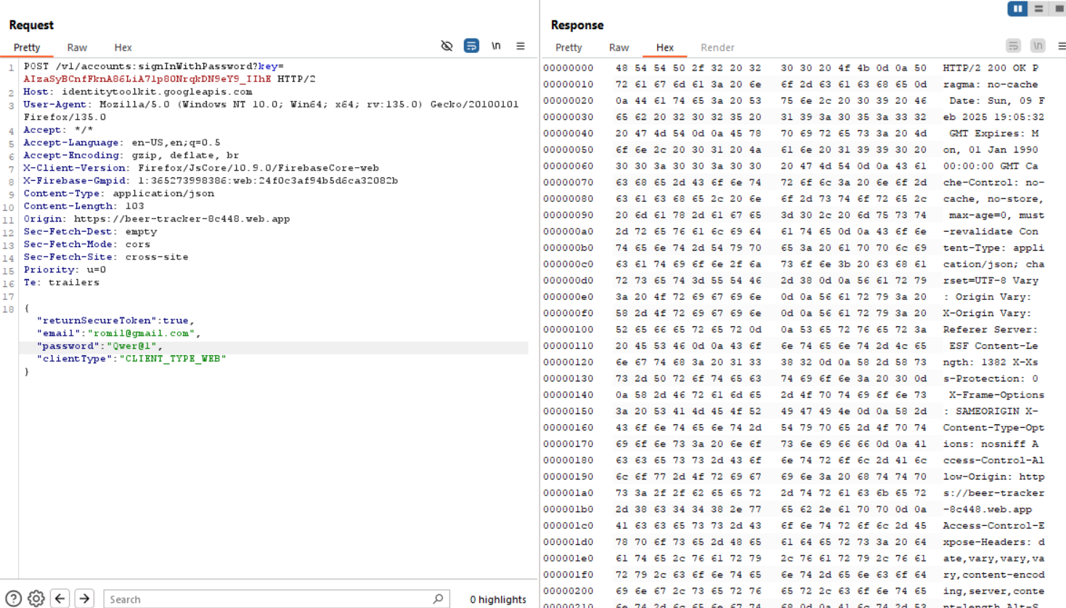

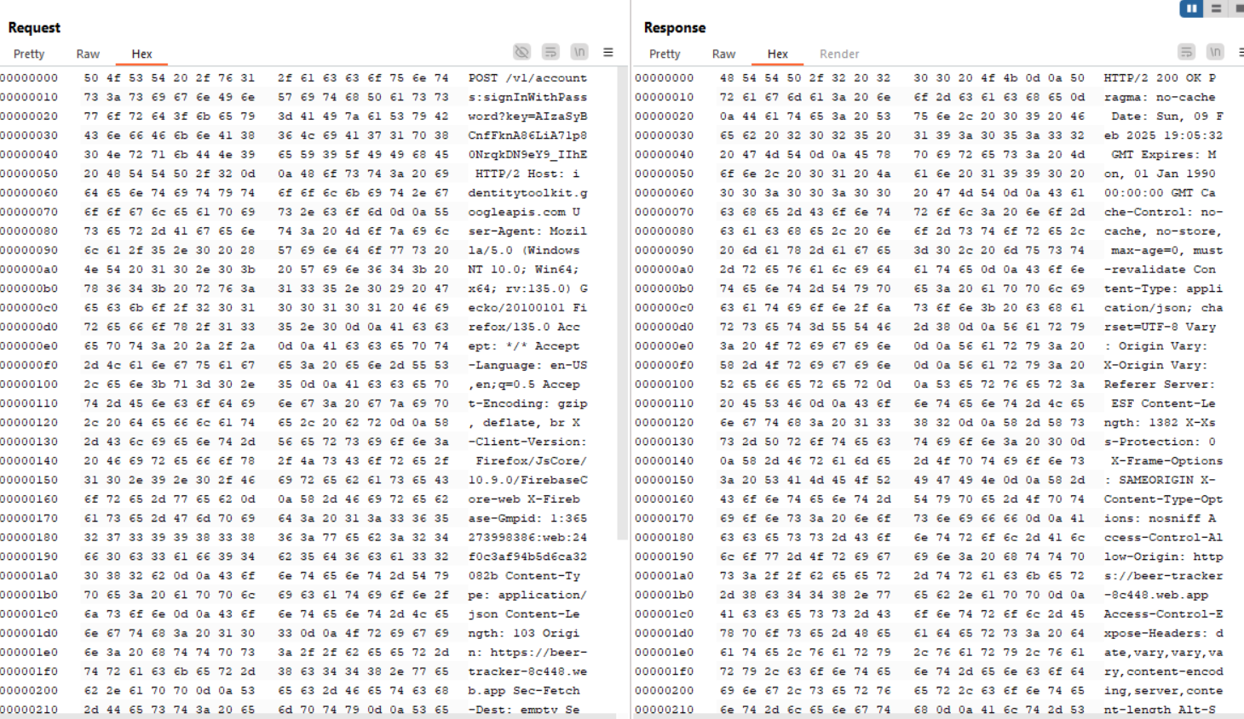

It has an Inspector section where the headers, cookies, and other parameters can be viewed separately.

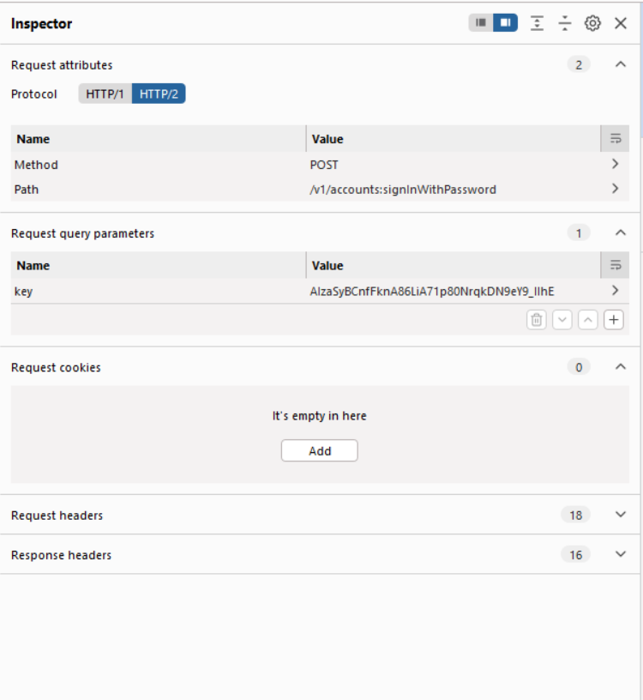

**Tool 4] Sequencer:**

The Burp Sequencer helps in identifying the randomness of a cookie or a token in a web

request. When a cookie is extremely random and is unpredictable defines the highest

security for the application.

**Step 1:** Begin by sending the request to Burp Sequencer.

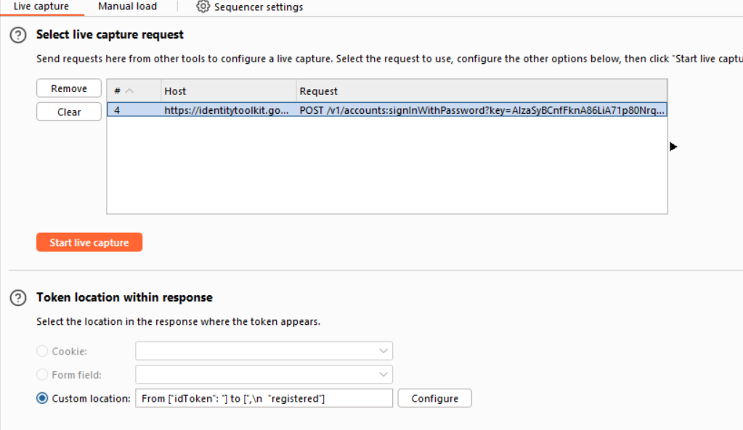

**Step 2:** Click on "Start Live Capture" to begin capturing tokens.

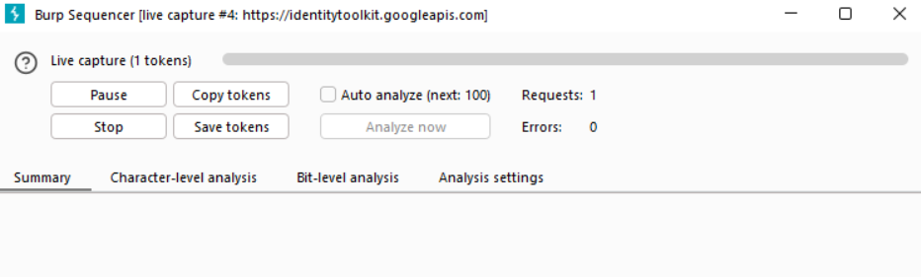

After Burp has captured a few tokens, click on "Stop" to halt the capture.

**Step 3:** Once the capture is complete, click on "Analyze Now."

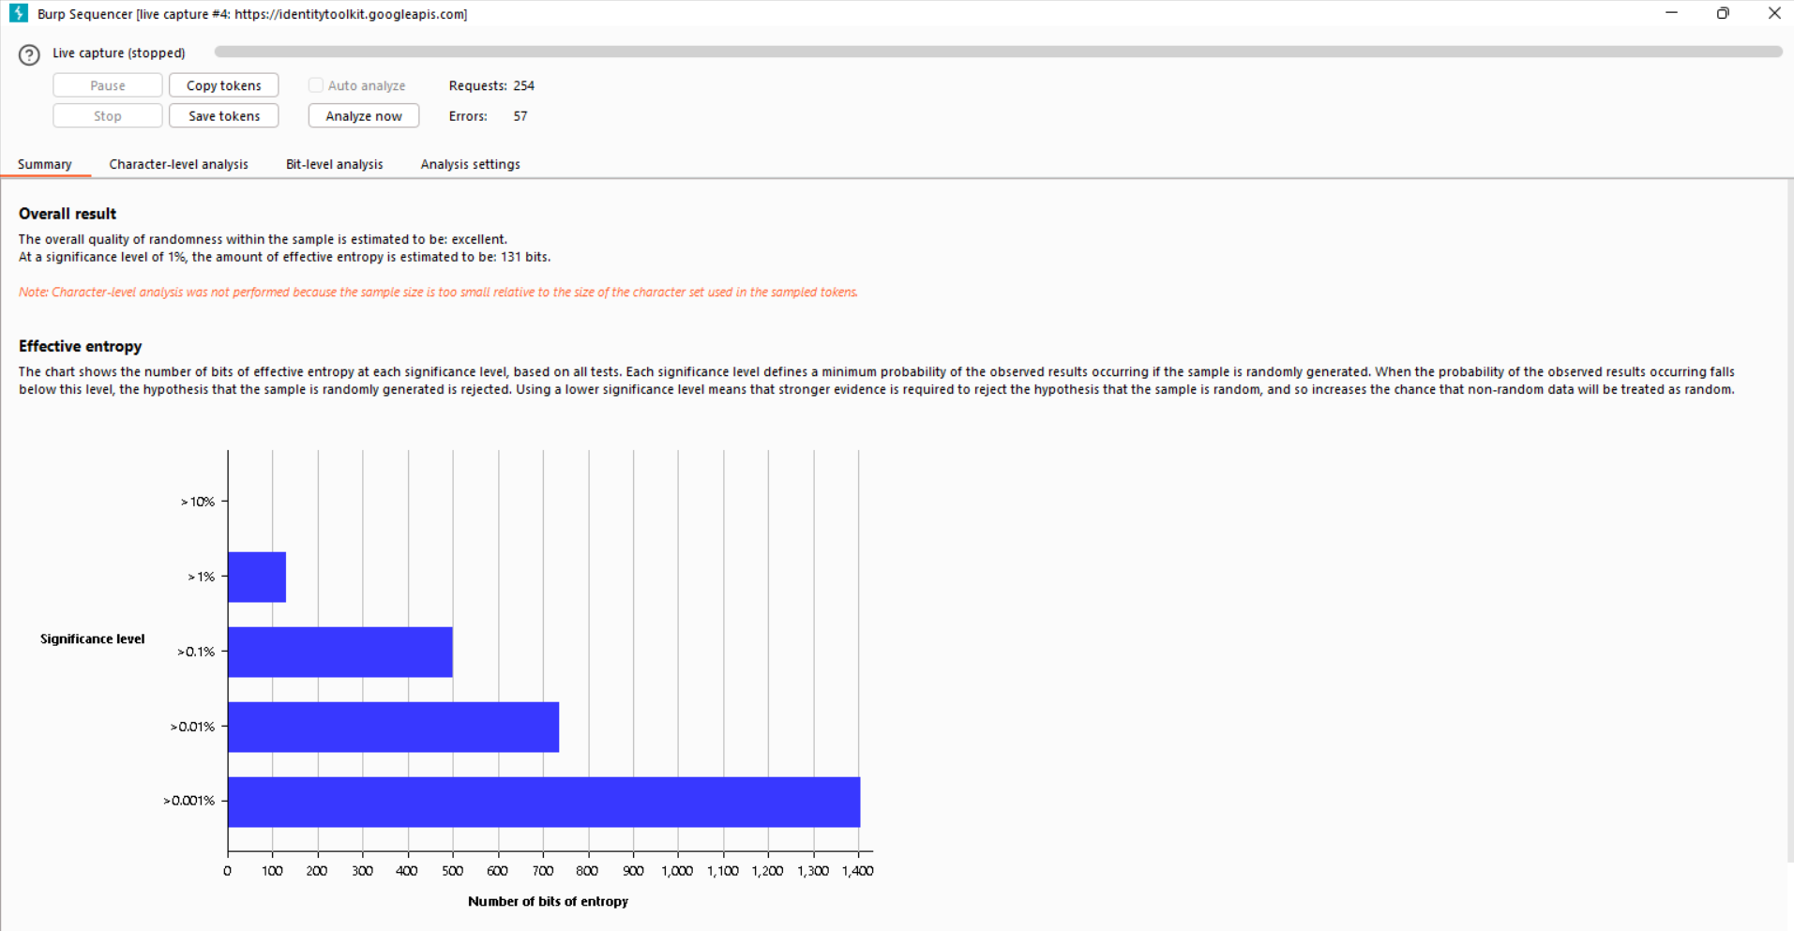

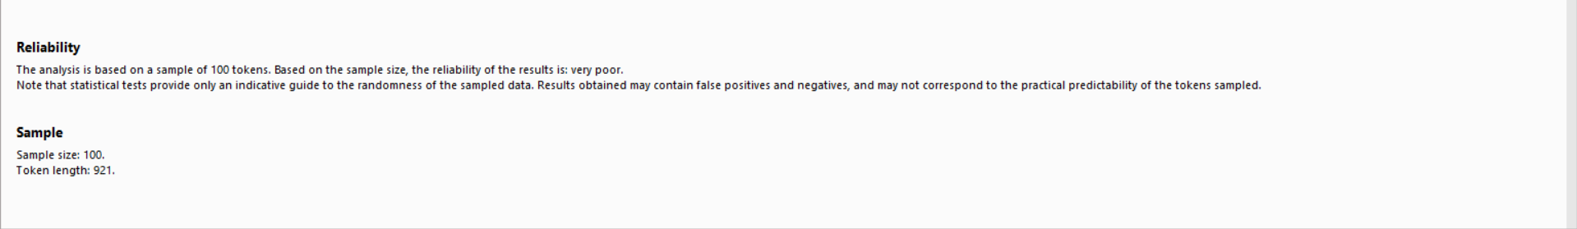

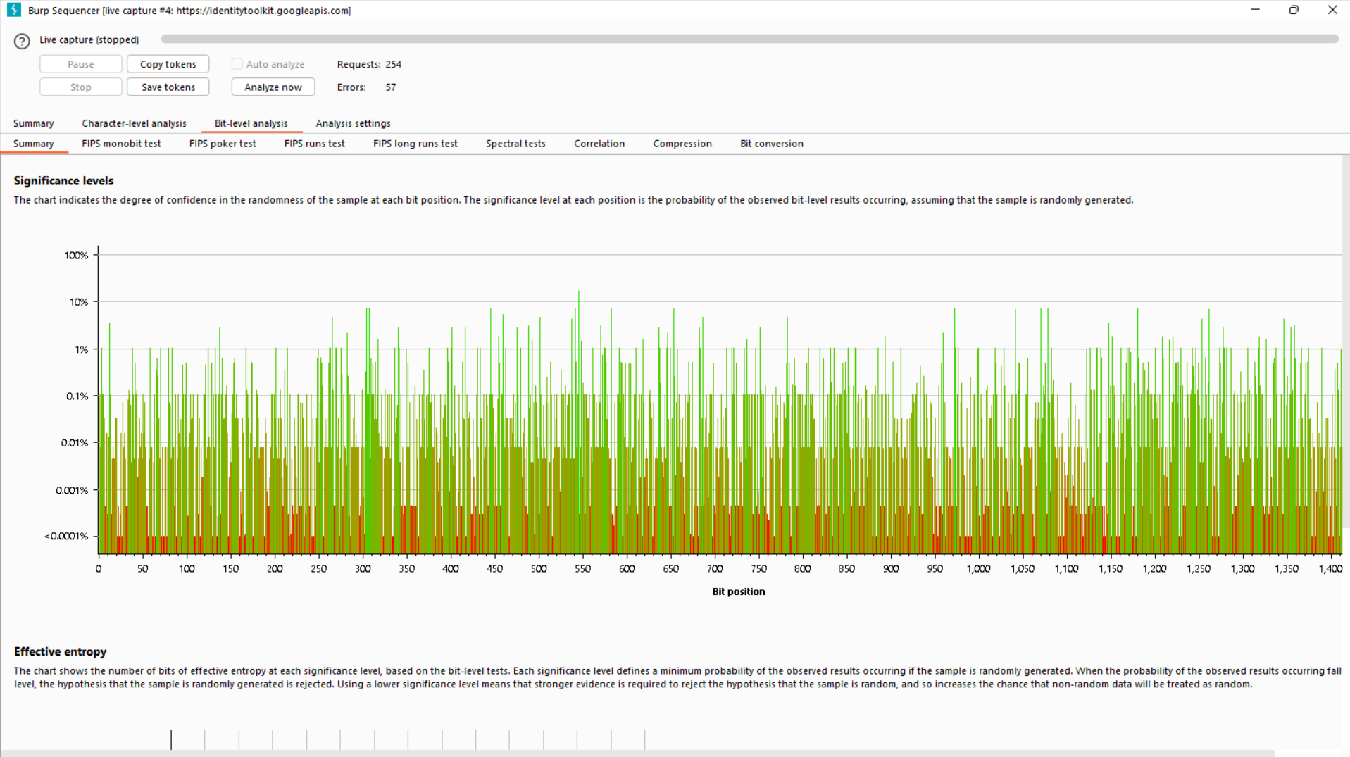

After the analysis is finished, Burp provides a summary using various tests and algorithms to assess the strength and randomness of the tokens/cookies.

The report shows that there are 131 unpredictable bits in each token/cookie, which indicates a high level of unpredictability.

**Tool 5] Decoder:**

The Burp Decoder assists in encoding and decoding text and provides Encoding and

Decoding formats in all these:

* Plain
* URL Encoding/Decoding
* HTML Encoding/Decoding
* Base64 Encoding/Decoding
* ASCII Encoding/Decoding
* Hex Encoding/Decoding
* Octal Encoding/Decoding
* Binary Encoding/Decoding
* Gzip Encoding/Decoding

It also provides Decoding & Encoding of various hashes such as:

* BLAKE2B-256
* GOST3411
* KECCAK-256, etc

Options for encoding:

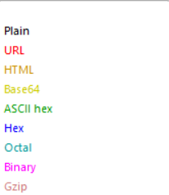

Options for decoding:

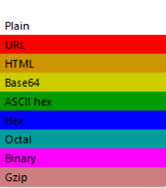

**Step 1:** Base64

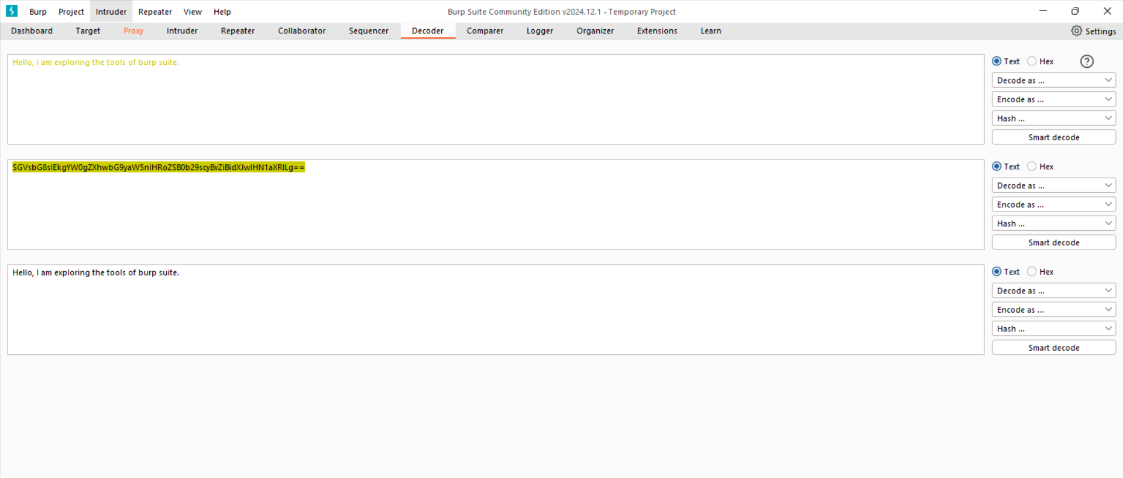

**Encoding to Base64:** Convert plaintext into Base64 format.

**Decoding from Base64:** Decode Base64 back into plaintext.

**Step 2:** HTML

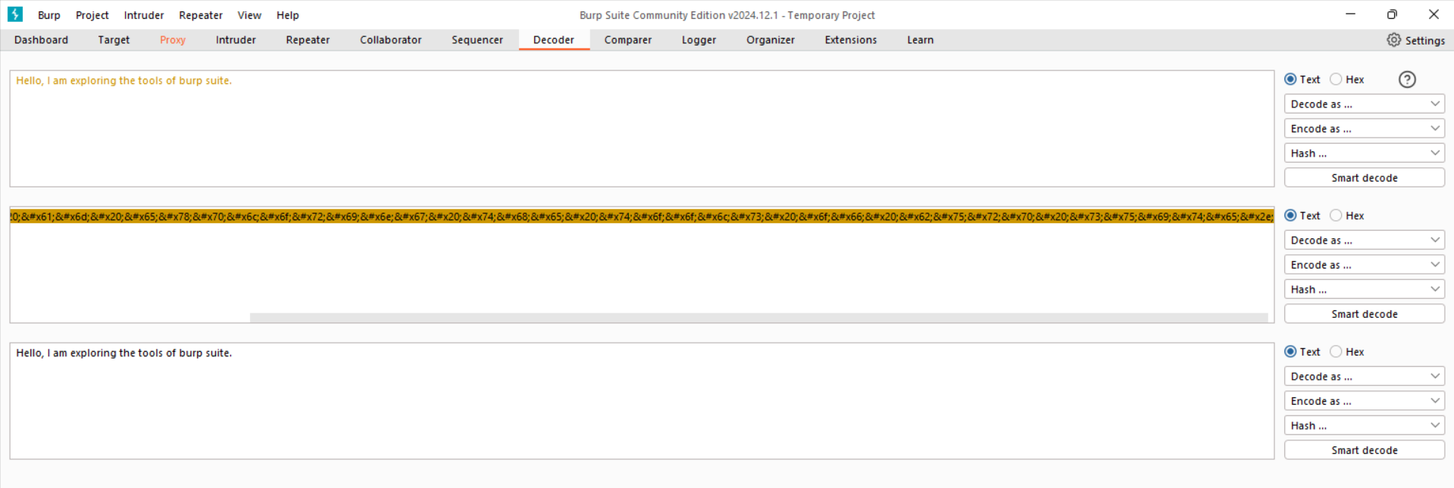

**Encoding to HTML:** Encode plain text into HTML format.

**Decoding from HTML:** Decode the HTML format back into plain text.

**Tool 6] Comparer:**

The Burp Comparer is a tool for comparing differences between two sets of data or

responses from an application. This tool can easily help find the changes between the data

or responses.

**Step 1:** Send two responses (one with valid credentials and one with invalid credentials) to the Comparer tool.

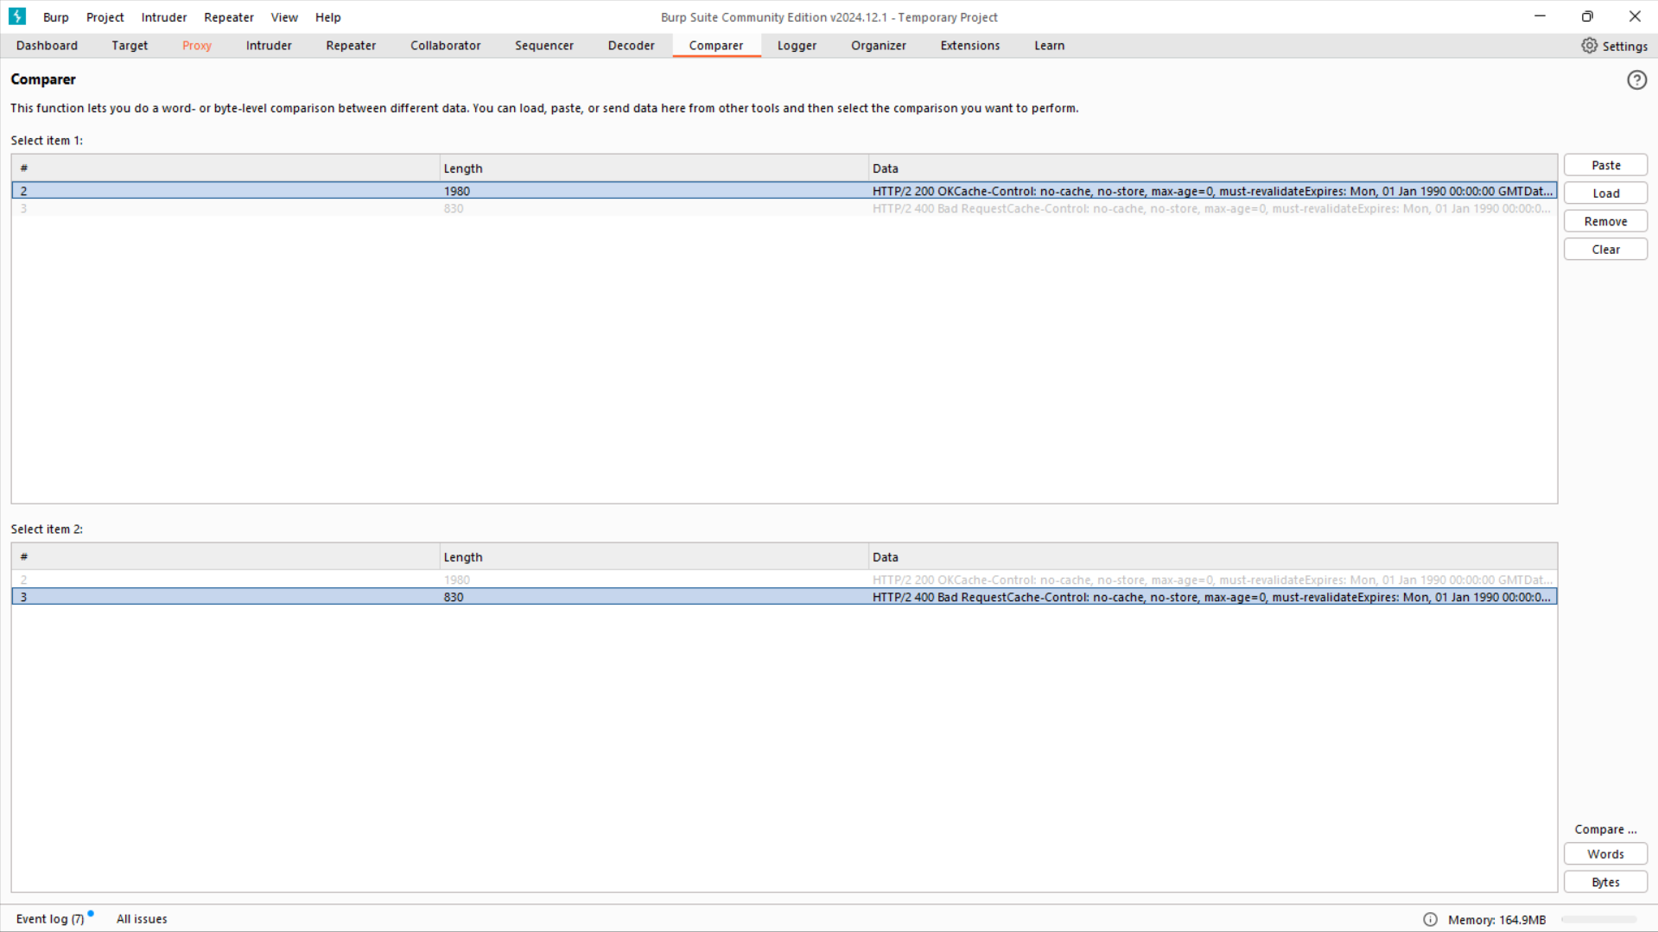

**Step 2:** In the Compare section, click on "Words" to view the comparison.

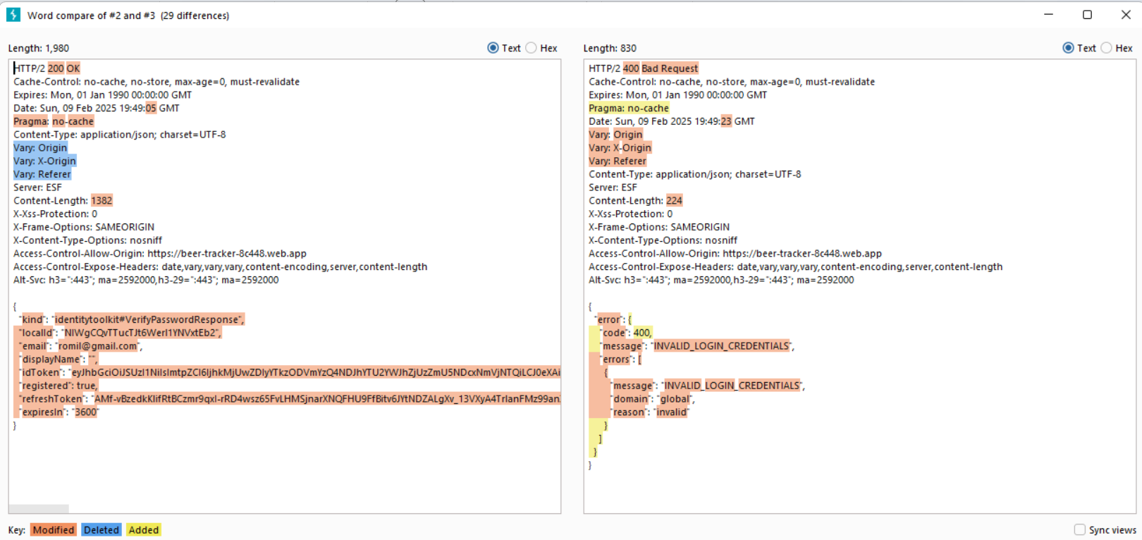

We can also view the responses in the comparison tab in **Hex** form.

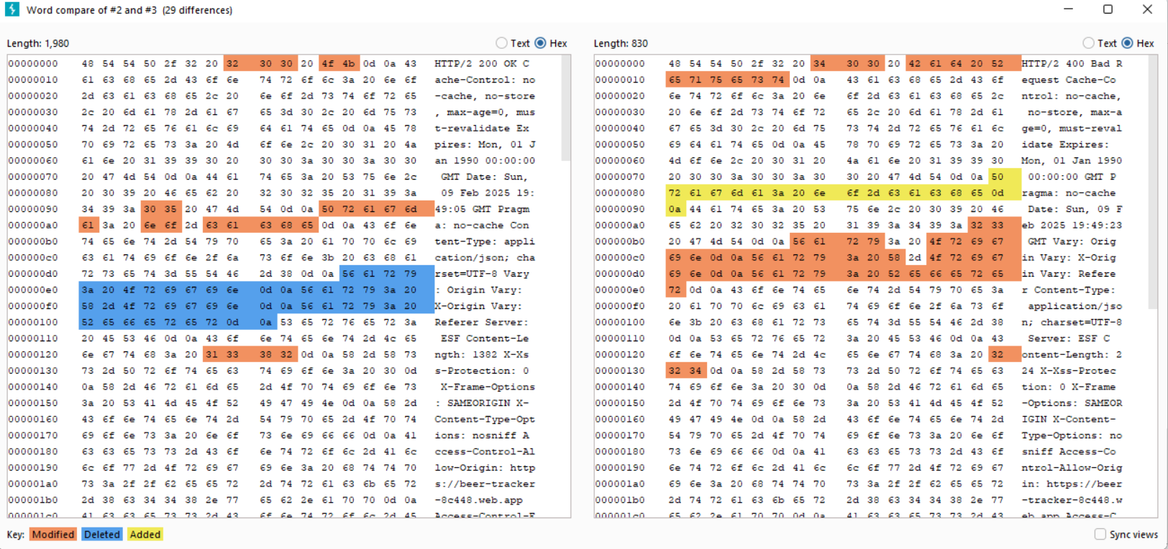

In addition to comparing words, we can also compare based on **bytes**.

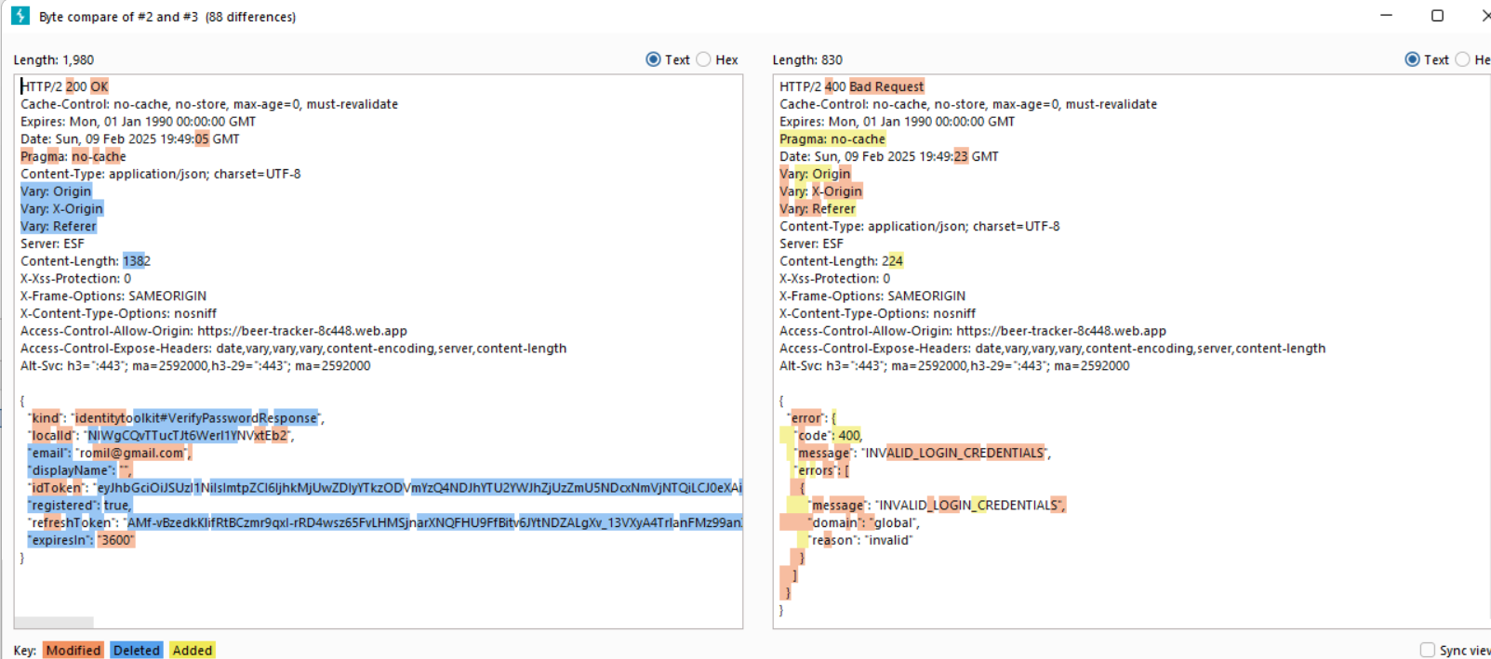

The comparison can also be viewed in **Hex** format to identify differences at the byte level.

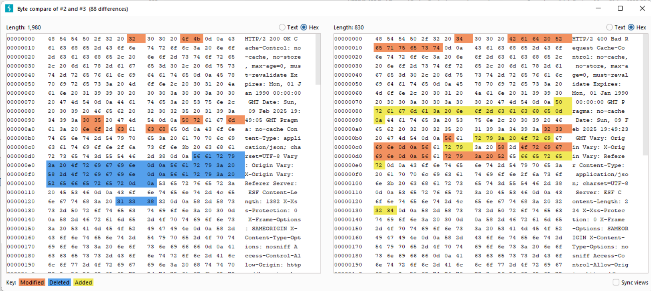

This section provides a summary of the differences between the two responses from the web application.

**ATTACKS:**

**1] Man in the Middle:**

Send a login request with invalid credentials:



When forwarding the request with incorrect credentials from Burp Suite, an error occurs during login:



Now, modifying the request with the correct credentials:





After modifying the request with valid credentials, the login is successful, and we are logged into the site as a user.

Hence, Burp Proxy can be used for Man-In-The-Middle (MITM).

**2] XSS Attack:**

**XSS Reflected:**

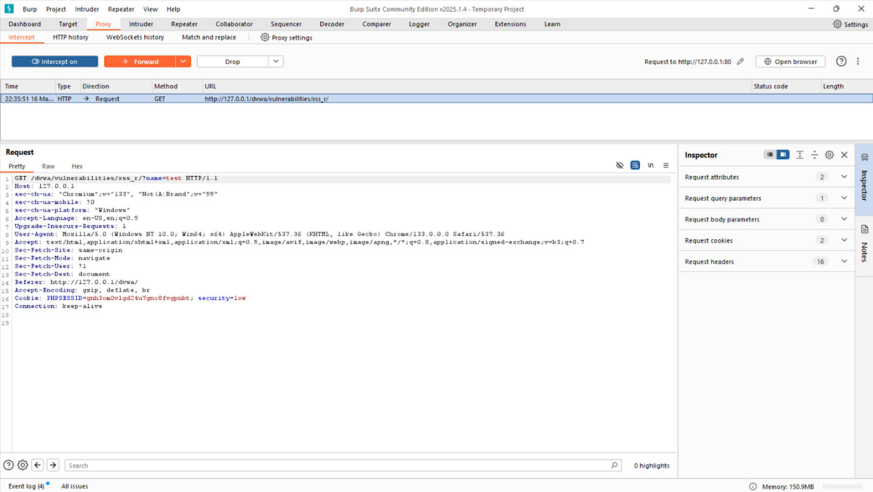

**Received the dvwa xss reflected request with the name field as test**

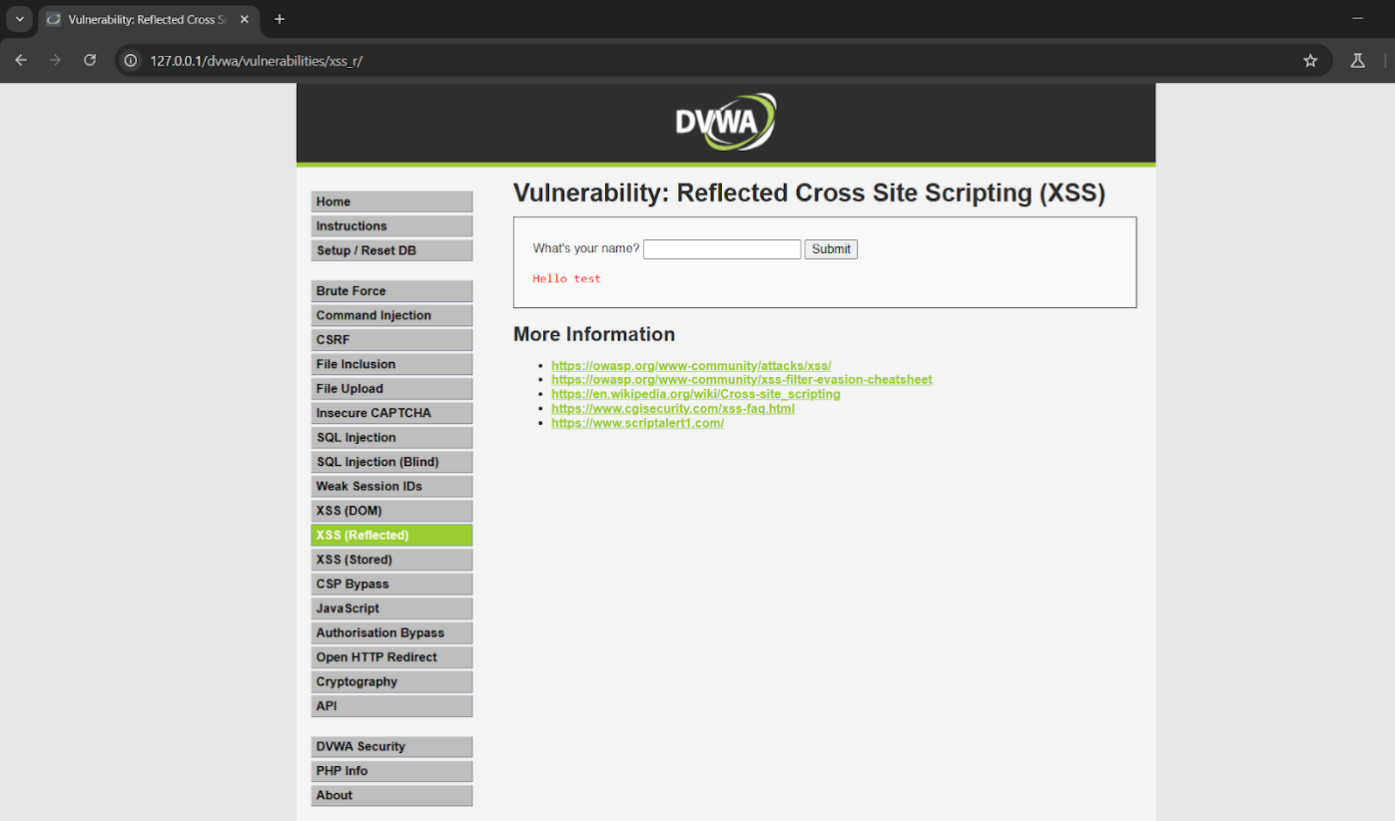

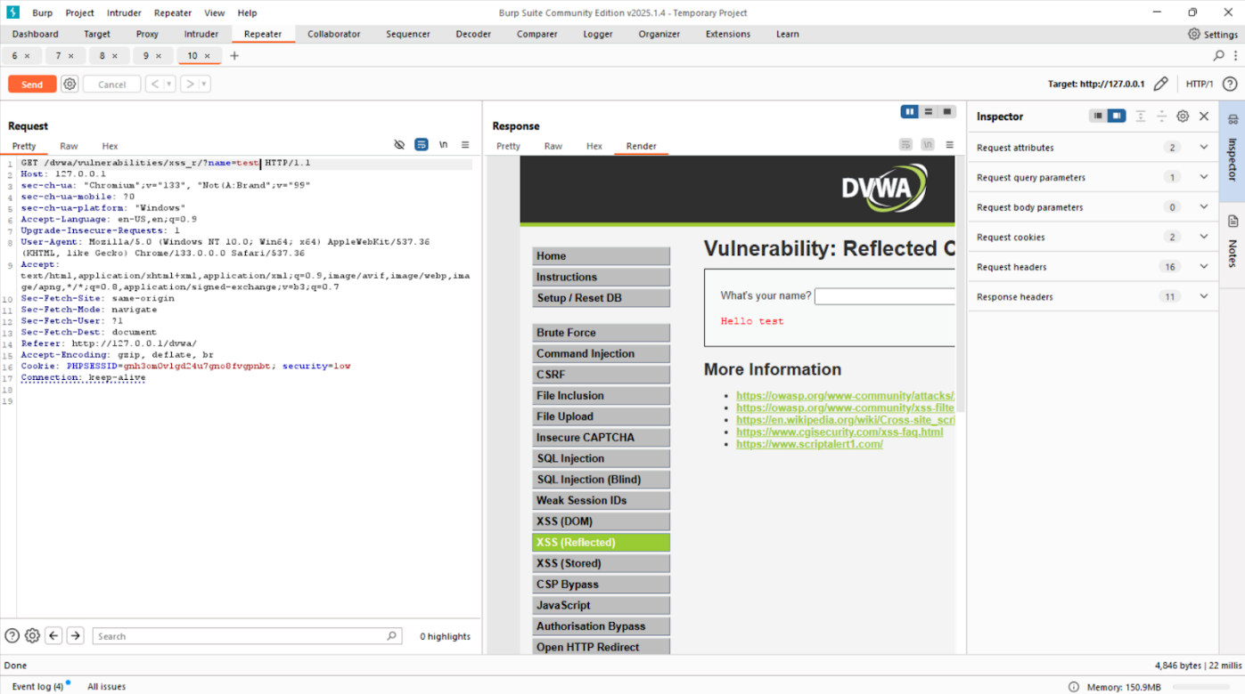

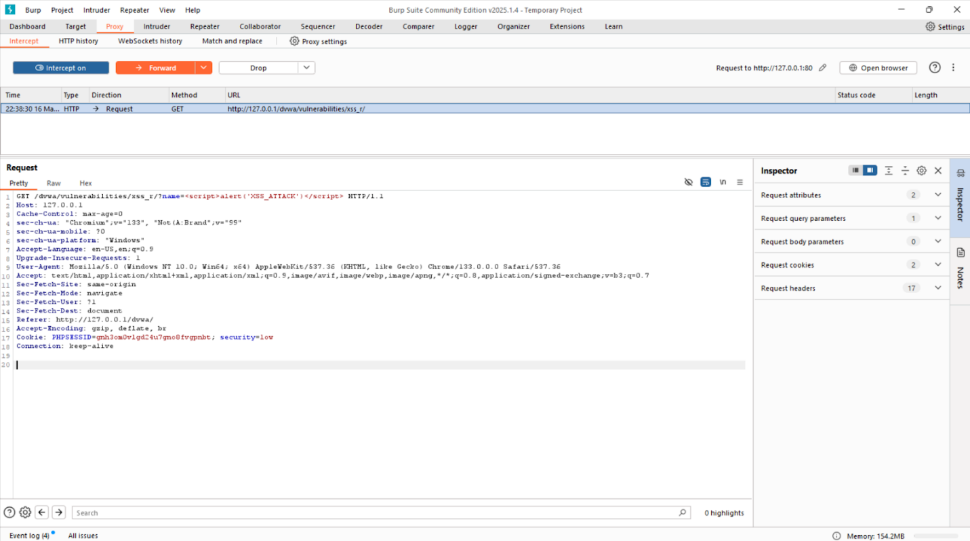

**Here changed the name field from test to a script payload for displaying an alert: <script>alert(‘XSS_ATTACK’)</script>**

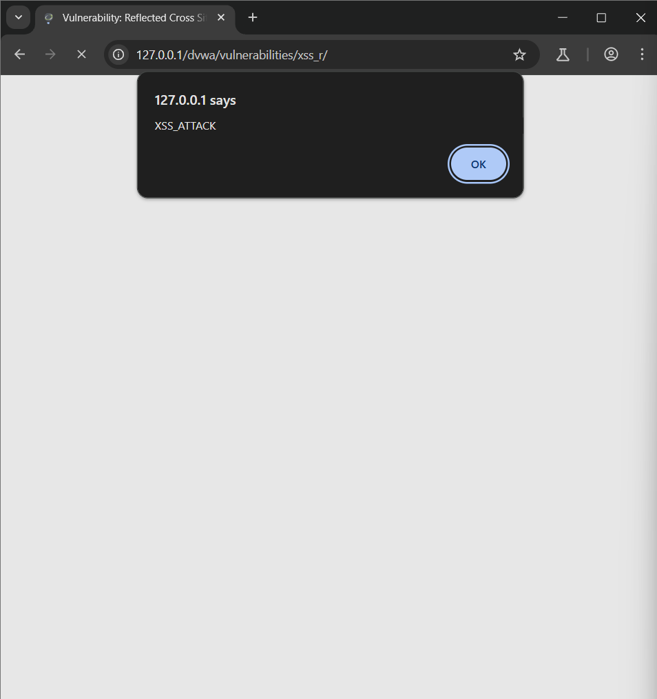

**XSS Stored:**

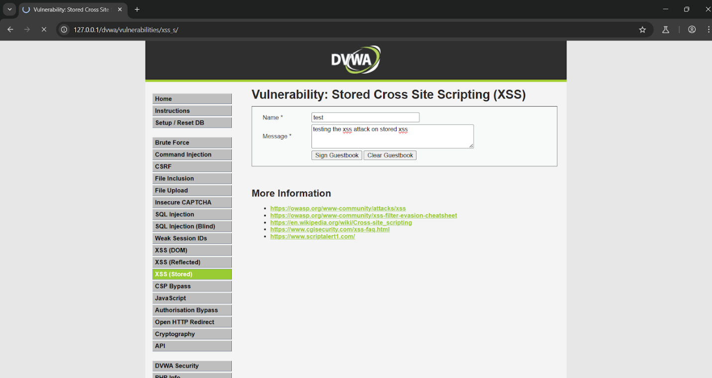

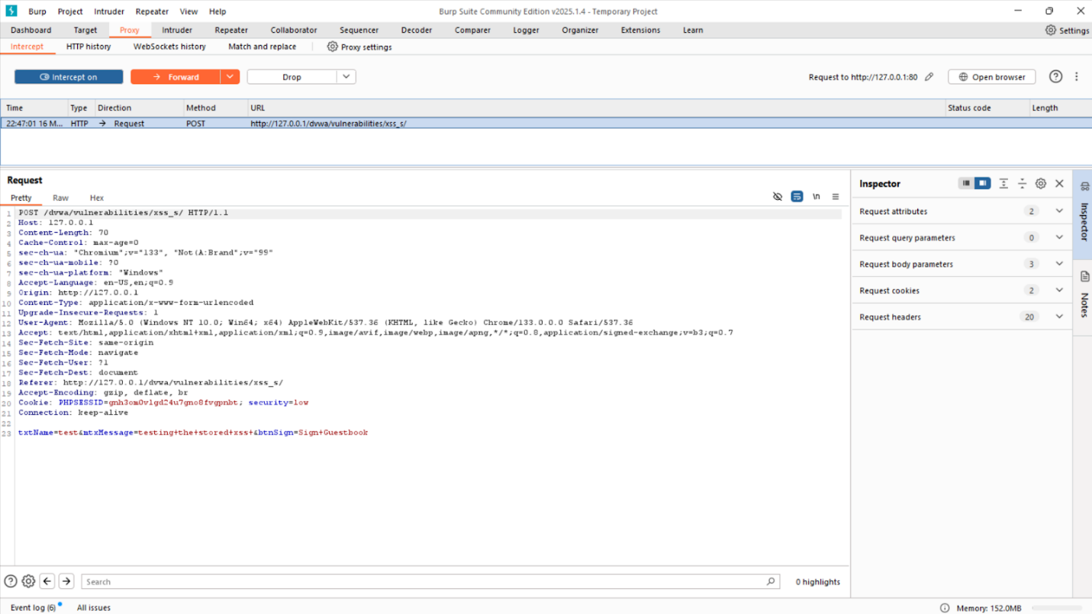

**Received dvwa xss stored request with txtname test1**

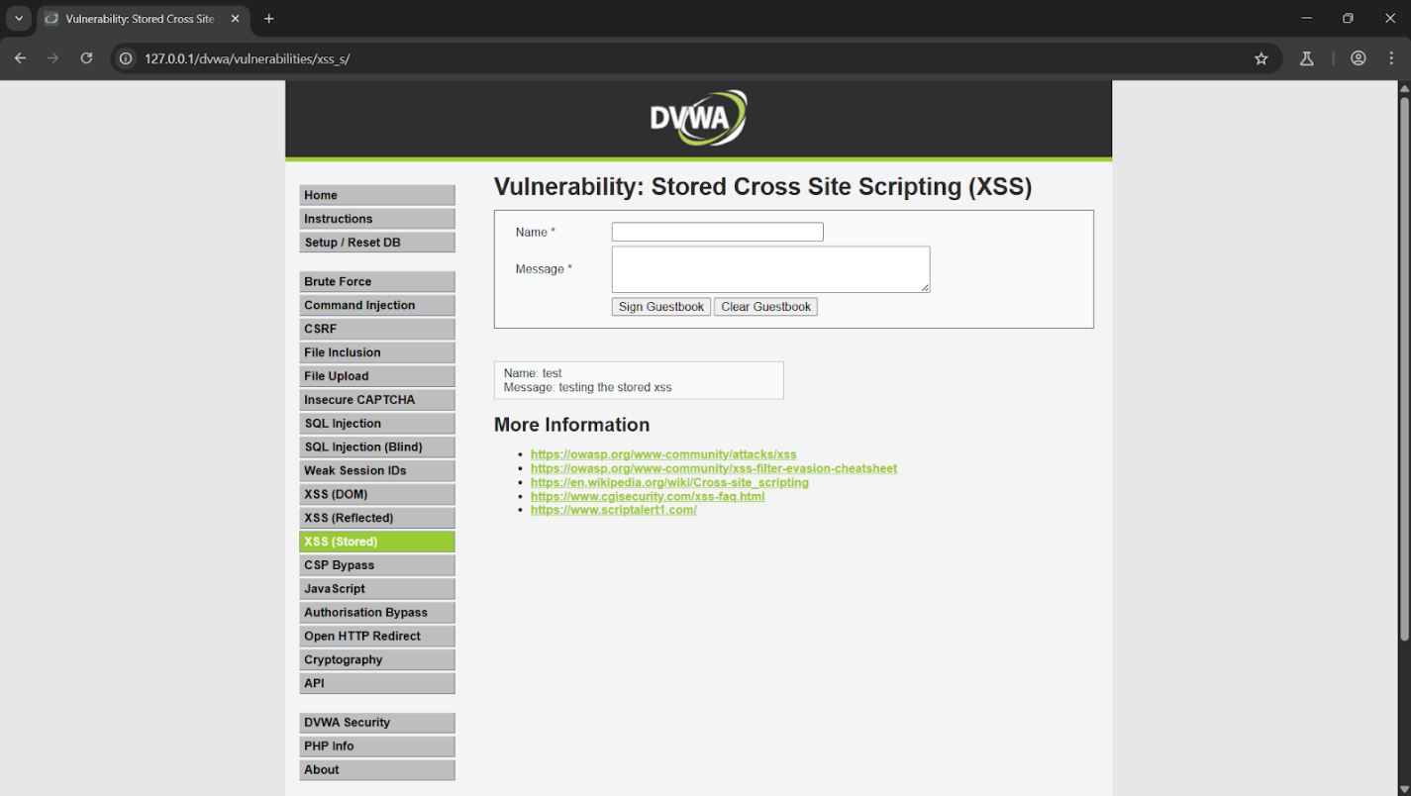

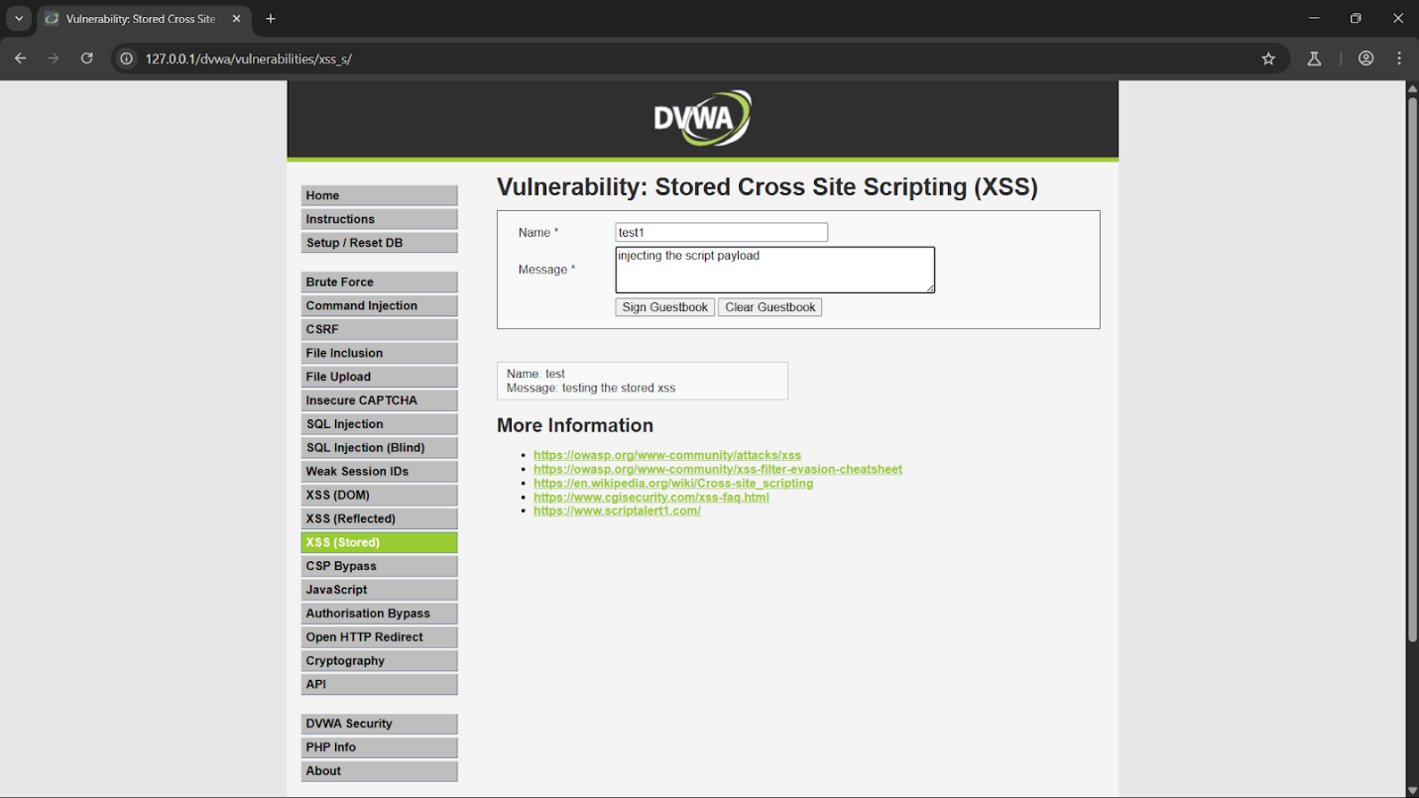

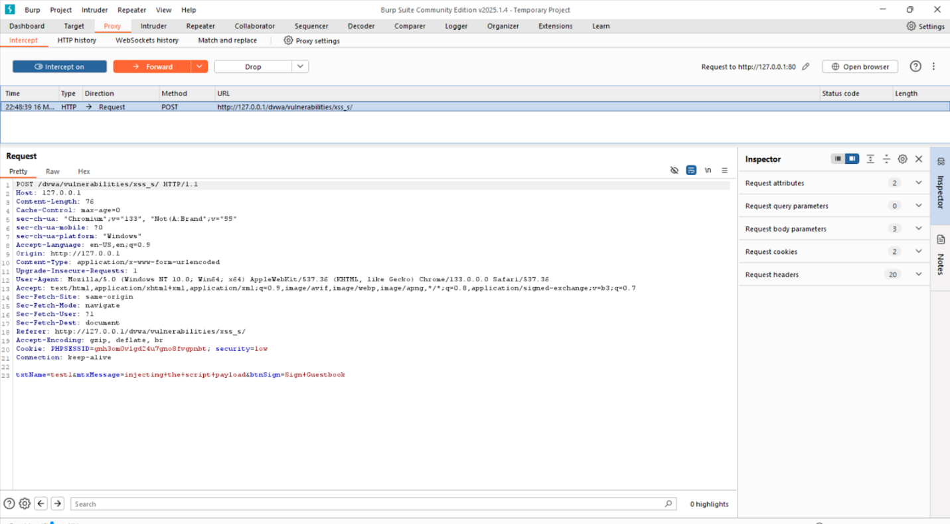

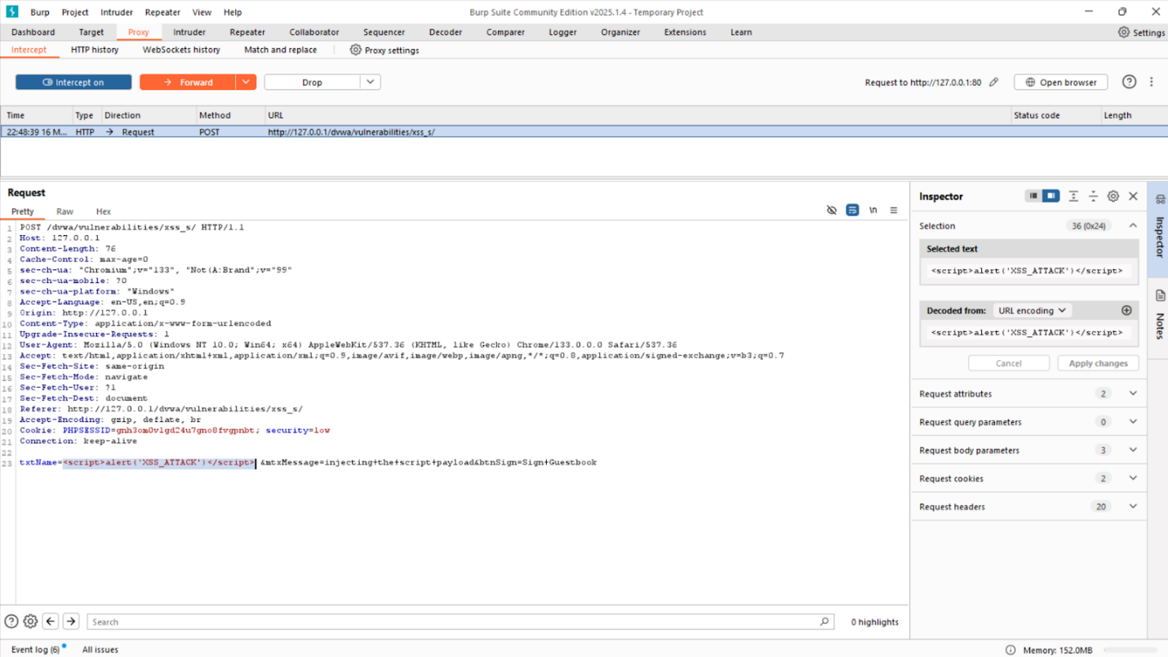

**Here changed the txtname field from test1 to a script payload for displaying alert: <script>alert(‘XSS_ATTACK’)</script>**

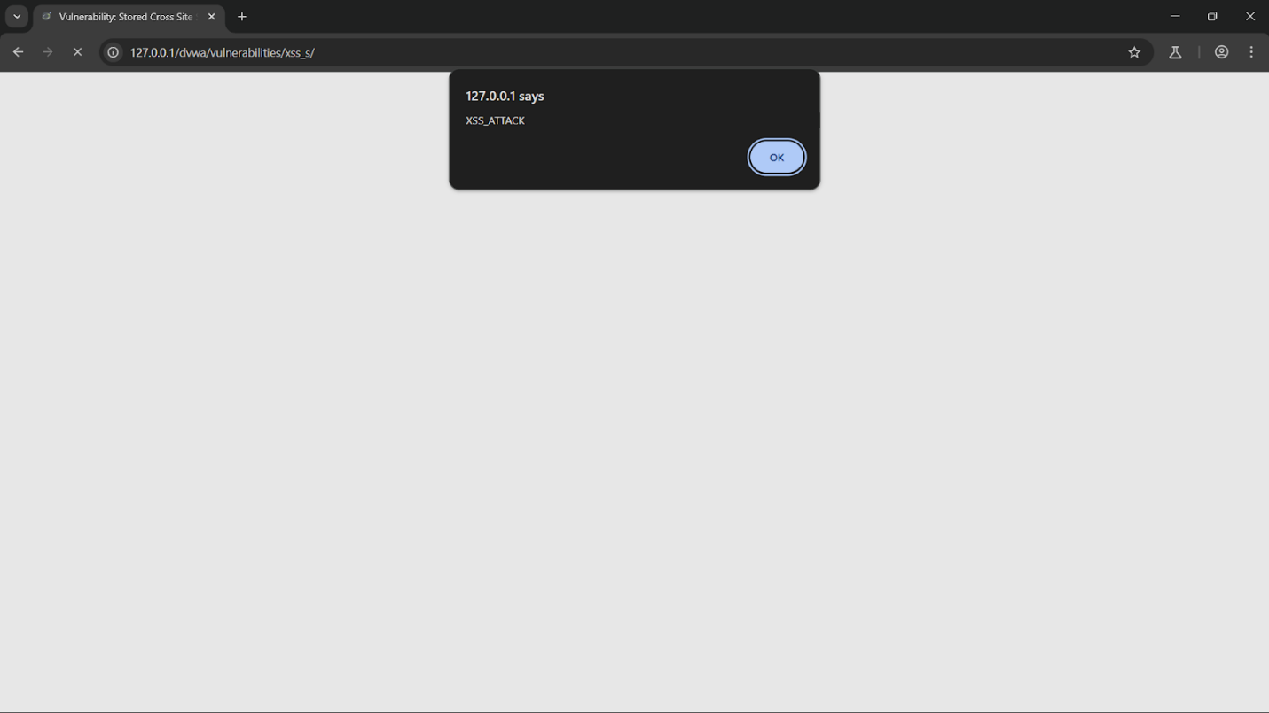

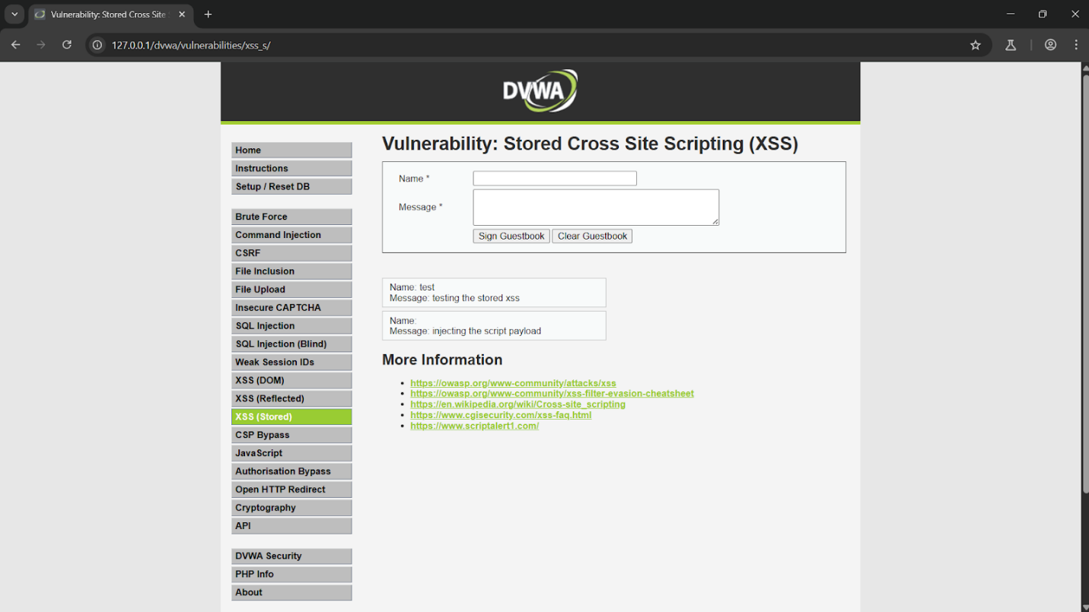

**GitHub Repository Link:** [Burp-Suite-Authentication-Testing](https://github.com/romill-09/burp-suite-authentication-testing)

**Drive Link:** [IS_IA-1_Drive_Link](https://drive.google.com/drive/folders/1xwdkIKmblfQ-onZd1GULcrJVTwCohJUO?usp=sharing)

**Demo Video Link:** [IS_IA-1_Demo_Link](https://youtu.be/aNvgtVMHKxY)

**Output:**

* Successfully intercepted and modified HTTP requests using Proxy.
* Performed brute-force attacks on a login page using Intruder.
* Manually tested vulnerabilities using Repeater.
* Analyzed session token randomness using Sequencer.
* Decoded and encoded data using Decoder.
* Compared two different responses using Comparer.

**Result/Discussion:**

This research demonstrates how Burp Suite significantly enhances penetration testing efficiency by automating vulnerability detection and enabling real-time analysis. The implementation of a Burp Suite extension streamlines authentication-based security tests, reducing manual effort and improving accuracy. By leveraging tools such as Proxy, Intruder, Repeater, and Sequencer, testers can systematically identify and exploit vulnerabilities in web applications.

**Limitations:**

* **Resource Consumption**:Burp Suite tools, especially when used together for large-scale testing, can consume significant system resources (CPU, RAM), causing performance degradation on lower-end systems.
* **False Positives/Negatives**:The tools, particularly Intruder and Repeater, may generate false positives or negatives in vulnerability detection, requiring manual verification of findings to avoid inaccurate conclusions.
* **Limited Out-of-the-Box Coverage**:Some tools may not cover all aspects of complex or non-standard web applications (e.g., WebSockets or advanced authentication mechanisms) without additional manual configuration or extensions.
* **Complex Configuration for HTTPS**:Intercepting and modifying HTTPS traffic requires additional configuration (e.g., importing Burp's SSL certificate into the browser), which can be cumbersome and prone to errors.
* **Learning Curve**:Burp Suite’s suite of tools can be overwhelming to new users, requiring expertise to maximize their effectiveness. Misconfiguration can lead to missed vulnerabilities or incomplete testing.
* **Limited Protocol Coverage**:Burp Suite primarily focuses on HTTP and HTTPS. Tools like Proxy, Intruder, and Repeater are not designed to work with non-web protocols (e.g., FTP, SMTP) unless additional extensions are installed.
* **Automated Attack Limitations**:Intruder’s automated attack capabilities, while useful, can be somewhat basic without customization, and may not effectively address sophisticated attack vectors or complex input validation.

**Limitations for each tool:**

**1. Proxy Tool**

* Cannot Intercept Some HTTPS Traffic → If TLS certificate pinning is enabled in mobile apps or modern web applications, Burp may fail to decrypt traffic.
* Breaks HTTP/2 and WebSockets in Some Cases → Some applications downgrade to HTTP/1.1 or fail when Burp intercepts traffic.

**2. Intruder Tool**

* Rate Limiting & IP Blocking → Servers detect automated brute-force attempts and block requests after multiple failed attempts.
* CAPTCHA Challenges Prevent Brute-Forcing → Many login forms implement CAPTCHA after a few failed login attempts, stopping automation.

**3. Repeater Tool**

* Cannot Automate Requests → Repeater is a manual tool and does not support sending multiple requests automatically like Intruder.
* No Session Management → Repeater does not automatically handle authentication tokens or session expiration.

**4. Sequencer Tool**

* Requires Large Token Samples → A meaningful analysis requires 1000+ tokens, making testing slow.
* Cannot Analyze Encrypted Tokens → If session tokens are hashed or encrypted, Sequencer cannot determine randomness.

**5. Decoder Tool**

* Cannot Crack Strongly Hashed Passwords → If data is hashed with SHA-256 or bcrypt, Burp cannot directly reverse it.
* No Built-in Decryption → Decoder does not support decrypting AES, RSA, or other encrypted data formats.

**6.Comparer Tool**

* Inefficient for Large Data Sets → Comparing very large responses manually is time-consuming.
* Cannot Detect Logical Differences → Only highlights byte/word differences but does not interpret meaning.

**Applications:**

* **Enterprise Security Testing:** Organizations use Burp Suite to safeguard their web applications from vulnerabilities.
* **Ethical Hacking & Bug Bounty Programs:** Security researchers and bug bounty hunters leverage it to find and exploit weaknesses in web applications.
* **Cybersecurity Training & Research:** Used in educational institutions to teach penetration testing techniques.

**References/Research Papers: (In IEEE format):**

1. Aishwarya Kore ,Taniya Hinduja , Aditi Sawant , Sanika Indorkar and Siddhant Rankhambe ,”Burp Suite Extension for Script based Attacks for Web Applications”, Proceedings of the Sixth International Conference on Electronics, Communication and Aerospace Technology (ICECA 2022). [[1]](https://drive.google.com/file/d/1sp85wr6Mbn5GqlmUWoaaS_6GJ_lN5ZCL/view?usp=drive_link)
2. Choudhary, R., Rawat, J., & Singh, G., "Comprehensive Exploration of Web Application Security Testing with Burp Suite Tools," *International Journal of Future Generation Communication and Networking*, vol. 16, no. 6, pp. 112-118, Jun. 2023. [[2]](https://drive.google.com/file/d/1HI0pZqEOtnrMpm_awLPktrSGGFVn7wdX/view?usp=drive_link)

### 

### Conclusion:

Burp Suite is a powerful tool that significantly enhances web application security testing by automating vulnerability detection, streamlining attack simulations, and providing in-depth request analysis. Through tools like Proxy, Intruder, Repeater, Sequencer, Decoder, and Comparer, testers can efficiently identify security flaws, assess authentication mechanisms, and analyze session management practices.

Despite its advantages, Burp Suite has limitations, including resource consumption, a steep learning curve, and the need for manual verification of automated findings. However, with proper configuration and expertise, it remains an essential tool for penetration testers, ethical hackers, and cybersecurity professionals.

The research highlights how Burp Suite’s automation capabilities reduce manual effort, increase testing accuracy, and improve overall security assessment efficiency. As web applications continue to evolve, mastering Burp Suite's tools will be crucial in identifying and mitigating potential threats effectively.